# Testcase 1 with results:

**Please enter cost of via**

10

**Please enter the x-dimension of the plane**

10

**Please enter the y-dimension of the plane**

10

**If no path available, do you want to swap source and target and try again?**

**If yes enter 1, if no enter 0**

0

**Do you want to do DFS in more than one layer and thus flood less?**

**If yes enter 1, if no enter 0**

0

**Enter x coordinate of source**

1

**Enter y coordinate of source**

1

**Enter z coordinate of source**

1

**Enter x coordinate of target**

2

**Enter y coordinate of target**

5

**Enter z coordinate of target**

3

**BACKTRACKING**

**0 0 0 0 0 0 0 0 0 0**

**0 -10 -10 -10 -10 -10 0 0 0 0**

**0 0 0 0 0 0 0 0 0 0**

**0 0 0 0 0 0 0 0 0 0**

**0 0 0 0 0 0 0 0 0 0**

**0 0 0 0 0 0 0 0 0 0**

**0 0 0 0 0 0 0 0 0 0**

**0 0 0 0 0 0 0 0 0 0**

**0 0 0 0 0 0 0 0 0 0**

**0 0 0 0 0 0 0 0 0 0**

**0 0 0 0 0 0 0 0 0 0**

**0 0 0 0 0 -10 0 0 0 0**

**0 0 0 0 0 -10 0 0 0 0**

**0 0 0 0 0 0 0 0 0 0**

**0 0 0 0 0 0 0 0 0 0**

**0 0 0 0 0 0 0 0 0 0**

**0 0 0 0 0 0 0 0 0 0**

**0 0 0 0 0 0 0 0 0 0**

**0 0 0 0 0 0 0 0 0 0**

**0 0 0 0 0 0 0 0 0 0**

**0 0 0 0 0 0 0 0 0 0**

**0 0 0 0 0 0 0 0 0 0**

**0 0 0 0 0 -10 0 0 0 0**

**0 0 0 0 0 0 0 0 0 0**

**0 0 0 0 0 0 0 0 0 0**

**0 0 0 0 0 0 0 0 0 0**

**0 0 0 0 0 0 0 0 0 0**

**0 0 0 0 0 0 0 0 0 0**

**0 0 0 0 0 0 0 0 0 0**

**0 0 0 0 0 0 0 0 0 0**

**Cost = 28**

**Execution time = 0.001565**

**Enter x coordinate of source**

7

**Enter y coordinate of source**

7

**Enter z coordinate of source**

3

**Enter x coordinate of target**

2

**Enter y coordinate of target**

5

**Enter z coordinate of target**

2

**BACKTRACKING**

**0 0 0 0 0 0 0 0 0 0**

**0 -10 -10 -10 -10 -10 0 0 0 0**

**0 0 0 0 0 0 0 0 0 0**

**0 0 0 0 0 0 0 0 0 0**

**0 0 0 0 0 0 0 0 0 0**

**0 0 0 0 0 0 0 0 0 0**

**0 0 0 0 0 0 0 0 0 0**

**0 0 0 0 0 0 0 0 0 0**

**0 0 0 0 0 0 0 0 0 0**

**0 0 0 0 0 0 0 0 0 0**

**0 0 0 0 0 0 0 0 0 0**

**0 0 0 0 0 -10 0 0 0 0**

**0 0 0 0 0 -11 0 0 0 0**

**0 0 0 0 0 -11 0 0 0 0**

**0 0 0 0 0 -11 0 0 0 0**

**0 0 0 0 0 -11 0 0 0 0**

**0 0 0 0 0 -11 0 0 0 0**

**0 0 0 0 0 -11 0 0 0 0**

**0 0 0 0 0 0 0 0 0 0**

**0 0 0 0 0 0 0 0 0 0**

**0 0 0 0 0 0 0 0 0 0**

**0 0 0 0 0 0 0 0 0 0**

**0 0 0 0 0 -10 0 0 0 0**

**0 0 0 0 0 0 0 0 0 0**

**0 0 0 0 0 0 0 0 0 0**

**0 0 0 0 0 0 0 0 0 0**

**0 0 0 0 0 0 0 0 0 0**

**0 0 0 0 0 -11 -11 -11 0 0**

**0 0 0 0 0 0 0 0 0 0**

**0 0 0 0 0 0 0 0 0 0**

**Cost = 19**

**Execution time = 0.001591**

**Enter x coordinate of source**

5

**Enter y coordinate of source**

4

**Enter z coordinate of source**

3

**Enter x coordinate of target**

1

**Enter y coordinate of target**

2

**Enter z coordinate of target**

1

**BACKTRACKING**

**0 0 0 0 0 0 0 0 0 0**

**0 -10 -12 -10 -10 -10 0 0 0 0**

**0 0 0 0 0 0 0 0 0 0**

**0 0 0 0 0 0 0 0 0 0**

**0 0 0 0 0 0 0 0 0 0**

**0 0 0 0 0 0 0 0 0 0**

**0 0 0 0 0 0 0 0 0 0**

**0 0 0 0 0 0 0 0 0 0**

**0 0 0 0 0 0 0 0 0 0**

**0 0 0 0 0 0 0 0 0 0**

**0 0 0 0 0 0 0 0 0 0**

**0 0 -12 0 0 -10 0 0 0 0**

**0 0 -12 0 0 -11 0 0 0 0**

**0 0 -12 0 0 -11 0 0 0 0**

**0 0 -12 0 0 -11 0 0 0 0**

**0 0 -12 0 0 -11 0 0 0 0**

**0 0 0 0 0 -11 0 0 0 0**

**0 0 0 0 0 -11 0 0 0 0**

**0 0 0 0 0 0 0 0 0 0**

**0 0 0 0 0 0 0 0 0 0**

**0 0 0 0 0 0 0 0 0 0**

**0 0 0 0 0 0 0 0 0 0**

**0 0 0 0 0 -10 0 0 0 0**

**0 0 0 0 0 0 0 0 0 0**

**0 0 0 0 0 0 0 0 0 0**

**0 0 -12 -12 -12 0 0 0 0 0**

**0 0 0 0 0 0 0 0 0 0**

**0 0 0 0 0 -11 -11 -11 0 0**

**0 0 0 0 0 0 0 0 0 0**

**0 0 0 0 0 0 0 0 0 0**

**Cost = 29**

**Execution time = 0.00134**

**Enter x coordinate of source**

9

**Enter y coordinate of source**

7

**Enter z coordinate of source**

3

**Enter x coordinate of target**

4

**Enter y coordinate of target**

1

**Enter z coordinate of target**

1

**BACKTRACKING**

**0 0 0 0 0 0 0 0 0 0**

**0 -10 -12 -10 -10 -10 0 0 0 0**

**0 0 0 0 0 0 0 0 0 0**

**0 0 0 0 0 0 0 0 0 0**

**0 -13 0 0 0 0 0 0 0 0**

**0 0 0 0 0 0 0 0 0 0**

**0 0 0 0 0 0 0 0 0 0**

**0 0 0 0 0 0 0 0 0 0**

**0 0 0 0 0 0 0 0 0 0**

**0 0 0 0 0 0 0 0 0 0**

**0 0 0 0 0 0 0 0 0 0**

**0 0 -12 0 0 -10 0 0 0 0**

**0 0 -12 0 0 -11 0 0 0 0**

**0 0 -12 0 0 -11 0 0 0 0**

**0 -13 -12 0 0 -11 0 0 0 0**

**0 -13 -12 0 0 -11 0 0 0 0**

**0 -13 0 0 0 -11 0 0 0 0**

**0 -13 0 0 0 -11 0 0 0 0**

**0 -13 0 0 0 0 0 0 0 0**

**0 -13 0 0 0 0 0 0 0 0**

**0 0 0 0 0 0 0 0 0 0**

**0 0 0 0 0 0 0 0 0 0**

**0 0 0 0 0 -10 0 0 0 0**

**0 0 0 0 0 0 0 0 0 0**

**0 0 0 0 0 0 0 0 0 0**

**0 0 -12 -12 -12 0 0 0 0 0**

**0 0 0 0 0 0 0 0 0 0**

**0 0 0 0 0 -11 -11 -11 0 0**

**0 0 0 0 0 0 0 0 0 0**

**0 -13 -13 -13 -13 -13 -13 -13 0 0**

**Cost = 34**

**Execution time = 0.001275**

**Enter x coordinate of source**

7

**Enter y coordinate of source**

8

**Enter z coordinate of source**

3

**Enter x coordinate of target**

1

**Enter y coordinate of target**

5

**Enter z coordinate of target**

1

**BACKTRACKING**

**0 0 0 0 0 0 0 0 0 0**

**0 -10 -12 -10 -10 -14 -14 -14 -14 0**

**0 0 0 0 0 0 0 0 0 0**

**0 0 0 0 0 0 0 0 0 0**

**0 -13 0 0 0 0 0 0 0 0**

**0 0 0 0 0 0 0 0 0 0**

**0 0 0 0 0 0 0 0 0 0**

**0 0 0 0 0 0 0 0 0 0**

**0 0 0 0 0 0 0 0 0 0**

**0 0 0 0 0 0 0 0 0 0**

**0 0 0 0 0 0 0 0 0 0**

**0 0 -12 0 0 -10 0 0 -14 0**

**0 0 -12 0 0 -11 0 0 -14 0**

**0 0 -12 0 0 -11 0 0 -14 0**

**0 -13 -12 0 0 -11 0 0 -14 0**

**0 -13 -12 0 0 -11 0 0 -14 0**

**0 -13 0 0 0 -11 0 0 -14 0**

**0 -13 0 0 0 -11 0 0 -14 0**

**0 -13 0 0 0 0 0 0 0 0**

**0 -13 0 0 0 0 0 0 0 0**

**0 0 0 0 0 0 0 0 0 0**

**0 0 0 0 0 0 0 0 0 0**

**0 0 0 0 0 -10 0 0 0 0**

**0 0 0 0 0 0 0 0 0 0**

**0 0 0 0 0 0 0 0 0 0**

**0 0 -12 -12 -12 0 0 0 0 0**

**0 0 0 0 0 0 0 0 0 0**

**0 0 0 0 0 -11 -11 -11 -14 0**

**0 0 0 0 0 0 0 0 0 0**

**0 -13 -13 -13 -13 -13 -13 -13 0 0**

**Cost = 32**

**Execution time = 0.001469**

**Enter x coordinate of source**

6

**Enter y coordinate of source**

8

**Enter z coordinate of source**

3

**Enter x coordinate of target**

1

**Enter y coordinate of target**

6

**Enter z coordinate of target**

1

**BACKTRACKING**

**0 0 0 0 0 0 0 0 0 0**

**0 -10 -12 -10 -10 -14 -15 -14 -14 0**

**0 0 0 0 0 0 0 0 0 0**

**0 0 0 0 0 0 0 0 0 0**

**0 -13 0 0 0 0 0 0 0 0**

**0 0 0 0 0 0 0 0 0 0**

**0 0 0 0 0 0 0 0 0 0**

**0 0 0 0 0 0 0 0 0 0**

**0 0 0 0 0 0 0 0 0 0**

**0 0 0 0 0 0 0 0 0 0**

**0 0 0 0 0 0 0 0 0 0**

**0 0 -12 0 0 -10 -15 0 -14 0**

**0 0 -12 0 0 -11 -15 0 -14 0**

**0 0 -12 0 0 -11 -15 0 -14 0**

**0 -13 -12 0 0 -11 -15 0 -14 0**

**0 -13 -12 0 0 -11 -15 0 -14 0**

**0 -13 0 0 0 -11 -15 0 -14 0**

**0 -13 0 0 0 -11 0 0 -14 0**

**0 -13 0 0 0 0 0 0 0 0**

**0 -13 0 0 0 0 0 0 0 0**

**0 0 0 0 0 0 0 0 0 0**

**0 0 0 0 0 0 0 0 0 0**

**0 0 0 0 0 -10 0 0 0 0**

**0 0 0 0 0 0 0 0 0 0**

**0 0 0 0 0 0 0 0 0 0**

**0 0 -12 -12 -12 0 0 0 0 0**

**0 0 0 0 0 0 -15 -15 -15 0**

**0 0 0 0 0 -11 -11 -11 -14 0**

**0 0 0 0 0 0 0 0 0 0**

**0 -13 -13 -13 -13 -13 -13 -13 0 0**

**Cost = 30**

**Execution time = 0.00156**

**Enter x coordinate of source**

-1

**Program ended with exit code: 0**

# Testcase 2 with results:

**Please enter cost of via**

10

**Please enter the x-dimension of the plane**

10

**Please enter the y-dimension of the plane**

10

**If no path available, do you want to swap source and target and try again?**

**If yes enter 1, if no enter 0**

0

**Do you want to do DFS in more than one layer and thus flood less?**

**If yes enter 1, if no enter 0**

1

**Enter x coordinate of source**

1

**Enter y coordinate of source**

1

**Enter z coordinate of source**

1

**Enter x coordinate of target**

2

**Enter y coordinate of target**

5

**Enter z coordinate of target**

3

**0 0 0 0 0 0 0 0 0 0**

**0 -10 -10 -10 -10 -10 0 0 0 0**

**0 0 0 0 0 0 0 0 0 0**

**0 0 0 0 0 0 0 0 0 0**

**0 0 0 0 0 0 0 0 0 0**

**0 0 0 0 0 0 0 0 0 0**

**0 0 0 0 0 0 0 0 0 0**

**0 0 0 0 0 0 0 0 0 0**

**0 0 0 0 0 0 0 0 0 0**

**0 0 0 0 0 0 0 0 0 0**

**0 0 0 0 0 0 0 0 0 0**

**0 0 0 0 0 -10 0 0 0 0**

**0 0 0 0 0 -10 0 0 0 0**

**0 0 0 0 0 0 0 0 0 0**

**0 0 0 0 0 0 0 0 0 0**

**0 0 0 0 0 0 0 0 0 0**

**0 0 0 0 0 0 0 0 0 0**

**0 0 0 0 0 0 0 0 0 0**

**0 0 0 0 0 0 0 0 0 0**

**0 0 0 0 0 0 0 0 0 0**

**0 0 0 0 0 0 0 0 0 0**

**0 0 0 0 0 0 0 0 0 0**

**0 0 0 0 0 -10 0 0 0 0**

**0 0 0 0 0 0 0 0 0 0**

**0 0 0 0 0 0 0 0 0 0**

**0 0 0 0 0 0 0 0 0 0**

**0 0 0 0 0 0 0 0 0 0**

**0 0 0 0 0 0 0 0 0 0**

**0 0 0 0 0 0 0 0 0 0**

**0 0 0 0 0 0 0 0 0 0**

**Cost = 28**

**Execution time = 0.001561**

**Enter x coordinate of source**

7

**Enter y coordinate of source**

7

**Enter z coordinate of source**

3

**Enter x coordinate of target**

2

**Enter y coordinate of target**

5

**Enter z coordinate of target**

2

**BACKTRACKING**

**0 0 0 0 0 0 0 0 0 0**

**0 -10 -10 -10 -10 -10 0 0 0 0**

**0 0 0 0 0 0 0 0 0 0**

**0 0 0 0 0 0 0 0 0 0**

**0 0 0 0 0 0 0 0 0 0**

**0 0 0 0 0 0 0 0 0 0**

**0 0 0 0 0 0 0 0 0 0**

**0 0 0 0 0 0 0 0 0 0**

**0 0 0 0 0 0 0 0 0 0**

**0 0 0 0 0 0 0 0 0 0**

**0 0 0 0 0 0 0 0 0 0**

**0 0 0 0 0 -10 0 0 0 0**

**0 0 0 0 0 -11 0 0 0 0**

**0 0 0 0 0 -11 0 0 0 0**

**0 0 0 0 0 -11 0 0 0 0**

**0 0 0 0 0 -11 0 0 0 0**

**0 0 0 0 0 -11 0 0 0 0**

**0 0 0 0 0 -11 0 0 0 0**

**0 0 0 0 0 0 0 0 0 0**

**0 0 0 0 0 0 0 0 0 0**

**0 0 0 0 0 0 0 0 0 0**

**0 0 0 0 0 0 0 0 0 0**

**0 0 0 0 0 -10 0 0 0 0**

**0 0 0 0 0 0 0 0 0 0**

**0 0 0 0 0 0 0 0 0 0**

**0 0 0 0 0 0 0 0 0 0**

**0 0 0 0 0 0 0 0 0 0**

**0 0 0 0 0 -11 -11 -11 0 0**

**0 0 0 0 0 0 0 0 0 0**

**0 0 0 0 0 0 0 0 0 0**

**Cost = 19**

**Execution time = 0.001516**

**Enter x coordinate of source**

5

**Enter y coordinate of source**

4

**Enter z coordinate of source**

3

**Enter x coordinate of target**

1

**Enter y coordinate of target**

2

**Enter z coordinate of target**

1

**0 0 0 0 0 0 0 0 0 0**

**0 -10 -10 -10 -10 -10 0 0 0 0**

**0 0 0 0 0 0 0 0 0 0**

**0 0 0 0 0 0 0 0 0 0**

**0 0 0 0 0 0 0 0 0 0**

**0 0 0 0 0 0 0 0 0 0**

**0 0 0 0 0 0 0 0 0 0**

**0 0 0 0 0 0 0 0 0 0**

**0 0 0 0 0 0 0 0 0 0**

**0 0 0 0 0 0 0 0 0 0**

**0 0 0 0 0 0 0 0 0 0**

**0 0 -12 0 0 -10 0 0 0 0**

**0 0 -12 0 0 -11 0 0 0 0**

**0 0 -12 0 0 -11 0 0 0 0**

**0 0 -12 0 0 -11 0 0 0 0**

**0 0 -12 0 0 -11 0 0 0 0**

**0 0 0 0 0 -11 0 0 0 0**

**0 0 0 0 0 -11 0 0 0 0**

**0 0 0 0 0 0 0 0 0 0**

**0 0 0 0 0 0 0 0 0 0**

**0 0 0 0 0 0 0 0 0 0**

**0 0 0 0 0 0 0 0 0 0**

**0 0 0 0 0 -10 0 0 0 0**

**0 0 0 0 0 0 0 0 0 0**

**0 0 0 0 0 0 0 0 0 0**

**0 0 -12 -12 -12 0 0 0 0 0**

**0 0 0 0 0 0 0 0 0 0**

**0 0 0 0 0 -11 -11 -11 0 0**

**0 0 0 0 0 0 0 0 0 0**

**0 0 0 0 0 0 0 0 0 0**

**Cost = 28**

**Execution time = 0.001433**

**Enter x coordinate of source**

9

**Enter y coordinate of source**

7

**Enter z coordinate of source**

3

**Enter x coordinate of target**

4

**Enter y coordinate of target**

1

**Enter z coordinate of target**

1

**0 0 0 0 0 0 0 0 0 0**

**0 -10 -10 -10 -10 -10 0 0 0 0**

**0 0 0 0 0 0 0 0 0 0**

**0 0 0 0 0 0 0 0 0 0**

**0 -13 0 0 0 0 0 0 0 0**

**0 0 0 0 0 0 0 0 0 0**

**0 0 0 0 0 0 0 0 0 0**

**0 0 0 0 0 0 0 0 0 0**

**0 0 0 0 0 0 0 0 0 0**

**0 0 0 0 0 0 0 0 0 0**

**0 0 0 0 0 0 0 0 0 0**

**0 0 -12 0 0 -10 0 0 0 0**

**0 0 -12 0 0 -11 0 0 0 0**

**0 0 -12 0 0 -11 0 0 0 0**

**0 -13 -12 0 0 -11 0 0 0 0**

**0 -13 -12 0 0 -11 0 0 0 0**

**0 -13 0 0 0 -11 0 0 0 0**

**0 -13 0 0 0 -11 0 0 0 0**

**0 -13 0 0 0 0 0 0 0 0**

**0 -13 0 0 0 0 0 0 0 0**

**0 0 0 0 0 0 0 0 0 0**

**0 0 0 0 0 0 0 0 0 0**

**0 0 0 0 0 -10 0 0 0 0**

**0 0 0 0 0 0 0 0 0 0**

**0 0 0 0 0 0 0 0 0 0**

**0 0 -12 -12 -12 0 0 0 0 0**

**0 0 0 0 0 0 0 0 0 0**

**0 0 0 0 0 -11 -11 -11 0 0**

**0 0 0 0 0 0 0 0 0 0**

**0 -13 -13 -13 -13 -13 -13 -13 0 0**

**Cost = 34**

**Execution time = 0.001467**

**Enter x coordinate of source**

7

**Enter y coordinate of source**

8

**Enter z coordinate of source**

3

**Enter x coordinate of target**

1

**Enter y coordinate of target**

5

**Enter z coordinate of target**

1

**BACKTRACKING**

**0 0 0 0 0 0 0 0 0 0**

**0 -10 -10 -10 -10 -14 -14 -14 -14 0**

**0 0 0 0 0 0 0 0 0 0**

**0 0 0 0 0 0 0 0 0 0**

**0 -13 0 0 0 0 0 0 0 0**

**0 0 0 0 0 0 0 0 0 0**

**0 0 0 0 0 0 0 0 0 0**

**0 0 0 0 0 0 0 0 0 0**

**0 0 0 0 0 0 0 0 0 0**

**0 0 0 0 0 0 0 0 0 0**

**0 0 0 0 0 0 0 0 0 0**

**0 0 -12 0 0 -10 0 0 -14 0**

**0 0 -12 0 0 -11 0 0 -14 0**

**0 0 -12 0 0 -11 0 0 -14 0**

**0 -13 -12 0 0 -11 0 0 -14 0**

**0 -13 -12 0 0 -11 0 0 -14 0**

**0 -13 0 0 0 -11 0 0 -14 0**

**0 -13 0 0 0 -11 0 0 -14 0**

**0 -13 0 0 0 0 0 0 0 0**

**0 -13 0 0 0 0 0 0 0 0**

**0 0 0 0 0 0 0 0 0 0**

**0 0 0 0 0 0 0 0 0 0**

**0 0 0 0 0 -10 0 0 0 0**

**0 0 0 0 0 0 0 0 0 0**

**0 0 0 0 0 0 0 0 0 0**

**0 0 -12 -12 -12 0 0 0 0 0**

**0 0 0 0 0 0 0 0 0 0**

**0 0 0 0 0 -11 -11 -11 -14 0**

**0 0 0 0 0 0 0 0 0 0**

**0 -13 -13 -13 -13 -13 -13 -13 0 0**

**Cost = 32**

**Execution time = 0.001545**

**Enter x coordinate of source**

6

**Enter y coordinate of source**

8

**Enter z coordinate of source**

3

**Enter x coordinate of target**

1

**Enter y coordinate of target**

6

**Enter z coordinate of target**

1

**0 0 0 0 0 0 0 0 0 0**

**0 -10 -10 -10 -10 -14 -14 -14 -14 0**

**0 0 0 0 0 0 0 0 0 0**

**0 0 0 0 0 0 0 0 0 0**

**0 -13 0 0 0 0 0 0 0 0**

**0 0 0 0 0 0 0 0 0 0**

**0 0 0 0 0 0 0 0 0 0**

**0 0 0 0 0 0 0 0 0 0**

**0 0 0 0 0 0 0 0 0 0**

**0 0 0 0 0 0 0 0 0 0**

**0 0 0 0 0 0 0 0 0 0**

**0 0 -12 0 0 -10 -15 0 -14 0**

**0 0 -12 0 0 -11 -15 0 -14 0**

**0 0 -12 0 0 -11 -15 0 -14 0**

**0 -13 -12 0 0 -11 -15 0 -14 0**

**0 -13 -12 0 0 -11 -15 0 -14 0**

**0 -13 0 0 0 -11 -15 0 -14 0**

**0 -13 0 0 0 -11 0 0 -14 0**

**0 -13 0 0 0 0 0 0 0 0**

**0 -13 0 0 0 0 0 0 0 0**

**0 0 0 0 0 0 0 0 0 0**

**0 0 0 0 0 0 0 0 0 0**

**0 0 0 0 0 -10 0 0 0 0**

**0 0 0 0 0 0 0 0 0 0**

**0 0 0 0 0 0 0 0 0 0**

**0 0 -12 -12 -12 0 0 0 0 0**

**0 0 0 0 0 0 -15 -15 -15 0**

**0 0 0 0 0 -11 -11 -11 -14 0**

**0 0 0 0 0 0 0 0 0 0**

**0 -13 -13 -13 -13 -13 -13 -13 0 0**

**Cost = 29**

**Execution time = 0.001314**

**Enter x coordinate of source**

-1

**Program ended with exit code: 0**

# Testcase 3 with results:

**Please enter cost of via**

10

**Please enter the x-dimension of the plane**

10

**Please enter the y-dimension of the plane**

10

**If no path available, do you want to swap source and target and try again?**

**If yes enter 1, if no enter 0**

1

**Do you want to do DFS in more than one layer and thus flood less?**

**If yes enter 1, if no enter 0**

0

**Enter x coordinate of source**

1

**Enter y coordinate of source**

1

**Enter z coordinate of source**

1

**Enter x coordinate of target**

2

**Enter y coordinate of target**

5

**Enter z coordinate of target**

3

**BACKTRACKING**

**0 0 0 0 0 0 0 0 0 0**

**0 -10 -10 -10 -10 -10 0 0 0 0**

**0 0 0 0 0 0 0 0 0 0**

**0 0 0 0 0 0 0 0 0 0**

**0 0 0 0 0 0 0 0 0 0**

**0 0 0 0 0 0 0 0 0 0**

**0 0 0 0 0 0 0 0 0 0**

**0 0 0 0 0 0 0 0 0 0**

**0 0 0 0 0 0 0 0 0 0**

**0 0 0 0 0 0 0 0 0 0**

**0 0 0 0 0 0 0 0 0 0**

**0 0 0 0 0 -10 0 0 0 0**

**0 0 0 0 0 -10 0 0 0 0**

**0 0 0 0 0 0 0 0 0 0**

**0 0 0 0 0 0 0 0 0 0**

**0 0 0 0 0 0 0 0 0 0**

**0 0 0 0 0 0 0 0 0 0**

**0 0 0 0 0 0 0 0 0 0**

**0 0 0 0 0 0 0 0 0 0**

**0 0 0 0 0 0 0 0 0 0**

**0 0 0 0 0 0 0 0 0 0**

**0 0 0 0 0 0 0 0 0 0**

**0 0 0 0 0 -10 0 0 0 0**

**0 0 0 0 0 0 0 0 0 0**

**0 0 0 0 0 0 0 0 0 0**

**0 0 0 0 0 0 0 0 0 0**

**0 0 0 0 0 0 0 0 0 0**

**0 0 0 0 0 0 0 0 0 0**

**0 0 0 0 0 0 0 0 0 0**

**0 0 0 0 0 0 0 0 0 0**

**Cost = 28**

**Execution time = 0.001452**

**Enter x coordinate of source**

7

**Enter y coordinate of source**

7

**Enter z coordinate of source**

3

**Enter x coordinate of target**

2

**Enter y coordinate of target**

5

**Enter z coordinate of target**

2

**BACKTRACKING**

**0 0 0 0 0 0 0 0 0 0**

**0 -10 -10 -10 -10 -10 0 0 0 0**

**0 0 0 0 0 0 0 0 0 0**

**0 0 0 0 0 0 0 0 0 0**

**0 0 0 0 0 0 0 0 0 0**

**0 0 0 0 0 0 0 0 0 0**

**0 0 0 0 0 0 0 0 0 0**

**0 0 0 0 0 0 0 0 0 0**

**0 0 0 0 0 0 0 0 0 0**

**0 0 0 0 0 0 0 0 0 0**

**0 0 0 0 0 0 0 0 0 0**

**0 0 0 0 0 -10 0 0 0 0**

**0 0 0 0 0 -11 0 0 0 0**

**0 0 0 0 0 -11 0 0 0 0**

**0 0 0 0 0 -11 0 0 0 0**

**0 0 0 0 0 -11 0 0 0 0**

**0 0 0 0 0 -11 0 0 0 0**

**0 0 0 0 0 -11 0 0 0 0**

**0 0 0 0 0 0 0 0 0 0**

**0 0 0 0 0 0 0 0 0 0**

**0 0 0 0 0 0 0 0 0 0**

**0 0 0 0 0 0 0 0 0 0**

**0 0 0 0 0 -10 0 0 0 0**

**0 0 0 0 0 0 0 0 0 0**

**0 0 0 0 0 0 0 0 0 0**

**0 0 0 0 0 0 0 0 0 0**

**0 0 0 0 0 0 0 0 0 0**

**0 0 0 0 0 -11 -11 -11 0 0**

**0 0 0 0 0 0 0 0 0 0**

**0 0 0 0 0 0 0 0 0 0**

**Cost = 19**

**Execution time = 0.001527**

**Enter x coordinate of source**

5

**Enter y coordinate of source**

4

**Enter z coordinate of source**

3

**Enter x coordinate of target**

1

**Enter y coordinate of target**

2

**Enter z coordinate of target**

1

**BACKTRACKING**

**0 0 0 0 0 0 0 0 0 0**

**0 -10 -12 -10 -10 -10 0 0 0 0**

**0 0 0 0 0 0 0 0 0 0**

**0 0 0 0 0 0 0 0 0 0**

**0 0 0 0 0 0 0 0 0 0**

**0 0 0 0 0 0 0 0 0 0**

**0 0 0 0 0 0 0 0 0 0**

**0 0 0 0 0 0 0 0 0 0**

**0 0 0 0 0 0 0 0 0 0**

**0 0 0 0 0 0 0 0 0 0**

**0 0 0 0 0 0 0 0 0 0**

**0 0 -12 0 0 -10 0 0 0 0**

**0 0 -12 0 0 -11 0 0 0 0**

**0 0 -12 0 0 -11 0 0 0 0**

**0 0 -12 0 0 -11 0 0 0 0**

**0 0 -12 0 0 -11 0 0 0 0**

**0 0 0 0 0 -11 0 0 0 0**

**0 0 0 0 0 -11 0 0 0 0**

**0 0 0 0 0 0 0 0 0 0**

**0 0 0 0 0 0 0 0 0 0**

**0 0 0 0 0 0 0 0 0 0**

**0 0 0 0 0 0 0 0 0 0**

**0 0 0 0 0 -10 0 0 0 0**

**0 0 0 0 0 0 0 0 0 0**

**0 0 0 0 0 0 0 0 0 0**

**0 0 -12 -12 -12 0 0 0 0 0**

**0 0 0 0 0 0 0 0 0 0**

**0 0 0 0 0 -11 -11 -11 0 0**

**0 0 0 0 0 0 0 0 0 0**

**0 0 0 0 0 0 0 0 0 0**

**Cost = 29**

**Execution time = 0.001286**

**Enter x coordinate of source**

9

**Enter y coordinate of source**

7

**Enter z coordinate of source**

3

**Enter x coordinate of target**

4

**Enter y coordinate of target**

1

**Enter z coordinate of target**

1

**BACKTRACKING**

**0 0 0 0 0 0 0 0 0 0**

**0 -10 -12 -10 -10 -10 0 0 0 0**

**0 0 0 0 0 0 0 0 0 0**

**0 0 0 0 0 0 0 0 0 0**

**0 -13 0 0 0 0 0 0 0 0**

**0 0 0 0 0 0 0 0 0 0**

**0 0 0 0 0 0 0 0 0 0**

**0 0 0 0 0 0 0 0 0 0**

**0 0 0 0 0 0 0 0 0 0**

**0 0 0 0 0 0 0 0 0 0**

**0 0 0 0 0 0 0 0 0 0**

**0 0 -12 0 0 -10 0 0 0 0**

**0 0 -12 0 0 -11 0 0 0 0**

**0 0 -12 0 0 -11 0 0 0 0**

**0 -13 -12 0 0 -11 0 0 0 0**

**0 -13 -12 0 0 -11 0 0 0 0**

**0 -13 0 0 0 -11 0 0 0 0**

**0 -13 0 0 0 -11 0 0 0 0**

**0 -13 0 0 0 0 0 0 0 0**

**0 -13 0 0 0 0 0 0 0 0**

**0 0 0 0 0 0 0 0 0 0**

**0 0 0 0 0 0 0 0 0 0**

**0 0 0 0 0 -10 0 0 0 0**

**0 0 0 0 0 0 0 0 0 0**

**0 0 0 0 0 0 0 0 0 0**

**0 0 -12 -12 -12 0 0 0 0 0**

**0 0 0 0 0 0 0 0 0 0**

**0 0 0 0 0 -11 -11 -11 0 0**

**0 0 0 0 0 0 0 0 0 0**

**0 -13 -13 -13 -13 -13 -13 -13 0 0**

**Cost = 34**

**Execution time = 0.001355**

**Enter x coordinate of source**

7

**Enter y coordinate of source**

8

**Enter z coordinate of source**

3

**Enter x coordinate of target**

1

**Enter y coordinate of target**

5

**Enter z coordinate of target**

1

**BACKTRACKING**

**0 0 0 0 0 0 0 0 0 0**

**0 -10 -12 -10 -10 -14 -14 -14 -14 0**

**0 0 0 0 0 0 0 0 0 0**

**0 0 0 0 0 0 0 0 0 0**

**0 -13 0 0 0 0 0 0 0 0**

**0 0 0 0 0 0 0 0 0 0**

**0 0 0 0 0 0 0 0 0 0**

**0 0 0 0 0 0 0 0 0 0**

**0 0 0 0 0 0 0 0 0 0**

**0 0 0 0 0 0 0 0 0 0**

**0 0 0 0 0 0 0 0 0 0**

**0 0 -12 0 0 -10 0 0 -14 0**

**0 0 -12 0 0 -11 0 0 -14 0**

**0 0 -12 0 0 -11 0 0 -14 0**

**0 -13 -12 0 0 -11 0 0 -14 0**

**0 -13 -12 0 0 -11 0 0 -14 0**

**0 -13 0 0 0 -11 0 0 -14 0**

**0 -13 0 0 0 -11 0 0 -14 0**

**0 -13 0 0 0 0 0 0 0 0**

**0 -13 0 0 0 0 0 0 0 0**

**0 0 0 0 0 0 0 0 0 0**

**0 0 0 0 0 0 0 0 0 0**

**0 0 0 0 0 -10 0 0 0 0**

**0 0 0 0 0 0 0 0 0 0**

**0 0 0 0 0 0 0 0 0 0**

**0 0 -12 -12 -12 0 0 0 0 0**

**0 0 0 0 0 0 0 0 0 0**

**0 0 0 0 0 -11 -11 -11 -14 0**

**0 0 0 0 0 0 0 0 0 0**

**0 -13 -13 -13 -13 -13 -13 -13 0 0**

**Cost = 32**

**Execution time = 0.001524**

**Enter x coordinate of source**

6

**Enter y coordinate of source**

8

**Enter z coordinate of source**

3

**Enter x coordinate of target**

1

**Enter y coordinate of target**

6

**Enter z coordinate of target**

1

**BACKTRACKING**

**0 0 0 0 0 0 0 0 0 0**

**0 -10 -12 -10 -10 -14 -15 -14 -14 0**

**0 0 0 0 0 0 0 0 0 0**

**0 0 0 0 0 0 0 0 0 0**

**0 -13 0 0 0 0 0 0 0 0**

**0 0 0 0 0 0 0 0 0 0**

**0 0 0 0 0 0 0 0 0 0**

**0 0 0 0 0 0 0 0 0 0**

**0 0 0 0 0 0 0 0 0 0**

**0 0 0 0 0 0 0 0 0 0**

**0 0 0 0 0 0 0 0 0 0**

**0 0 -12 0 0 -10 -15 0 -14 0**

**0 0 -12 0 0 -11 -15 0 -14 0**

**0 0 -12 0 0 -11 -15 0 -14 0**

**0 -13 -12 0 0 -11 -15 0 -14 0**

**0 -13 -12 0 0 -11 -15 0 -14 0**

**0 -13 0 0 0 -11 -15 0 -14 0**

**0 -13 0 0 0 -11 0 0 -14 0**

**0 -13 0 0 0 0 0 0 0 0**

**0 -13 0 0 0 0 0 0 0 0**

**0 0 0 0 0 0 0 0 0 0**

**0 0 0 0 0 0 0 0 0 0**

**0 0 0 0 0 -10 0 0 0 0**

**0 0 0 0 0 0 0 0 0 0**

**0 0 0 0 0 0 0 0 0 0**

**0 0 -12 -12 -12 0 0 0 0 0**

**0 0 0 0 0 0 -15 -15 -15 0**

**0 0 0 0 0 -11 -11 -11 -14 0**

**0 0 0 0 0 0 0 0 0 0**

**0 -13 -13 -13 -13 -13 -13 -13 0 0**

**Cost = 30**

**Execution time = 0.00147**

**Enter x coordinate of source**

-1

**Program ended with exit code: 0**

# Testcase 4 with results:

**Please enter cost of via**

10

**Please enter the x-dimension of the plane**

10

**Please enter the y-dimension of the plane**

10

**If no path available, do you want to swap source and target and try again?**

**If yes enter 1, if no enter 0**

1

**Do you want to do DFS in more than one layer and thus flood less?**

**If yes enter 1, if no enter 0**

1

**Enter x coordinate of source**

1

**Enter y coordinate of source**

1

**Enter z coordinate of source**

1

**Enter x coordinate of target**

2

**Enter y coordinate of target**

5

**Enter z coordinate of target**

3

**0 0 0 0 0 0 0 0 0 0**

**0 -10 -10 -10 -10 -10 0 0 0 0**

**0 0 0 0 0 0 0 0 0 0**

**0 0 0 0 0 0 0 0 0 0**

**0 0 0 0 0 0 0 0 0 0**

**0 0 0 0 0 0 0 0 0 0**

**0 0 0 0 0 0 0 0 0 0**

**0 0 0 0 0 0 0 0 0 0**

**0 0 0 0 0 0 0 0 0 0**

**0 0 0 0 0 0 0 0 0 0**

**0 0 0 0 0 0 0 0 0 0**

**0 0 0 0 0 -10 0 0 0 0**

**0 0 0 0 0 -10 0 0 0 0**

**0 0 0 0 0 0 0 0 0 0**

**0 0 0 0 0 0 0 0 0 0**

**0 0 0 0 0 0 0 0 0 0**

**0 0 0 0 0 0 0 0 0 0**

**0 0 0 0 0 0 0 0 0 0**

**0 0 0 0 0 0 0 0 0 0**

**0 0 0 0 0 0 0 0 0 0**

**0 0 0 0 0 0 0 0 0 0**

**0 0 0 0 0 0 0 0 0 0**

**0 0 0 0 0 -10 0 0 0 0**

**0 0 0 0 0 0 0 0 0 0**

**0 0 0 0 0 0 0 0 0 0**

**0 0 0 0 0 0 0 0 0 0**

**0 0 0 0 0 0 0 0 0 0**

**0 0 0 0 0 0 0 0 0 0**

**0 0 0 0 0 0 0 0 0 0**

**0 0 0 0 0 0 0 0 0 0**

**Cost = 28**

**Execution time = 0.001533**

**Enter x coordinate of source**

7

**Enter y coordinate of source**

7

**Enter z coordinate of source**

3

**Enter x coordinate of target**

2

**Enter y coordinate of target**

5

**Enter z coordinate of target**

2

**BACKTRACKING**

**0 0 0 0 0 0 0 0 0 0**

**0 -10 -10 -10 -10 -10 0 0 0 0**

**0 0 0 0 0 0 0 0 0 0**

**0 0 0 0 0 0 0 0 0 0**

**0 0 0 0 0 0 0 0 0 0**

**0 0 0 0 0 0 0 0 0 0**

**0 0 0 0 0 0 0 0 0 0**

**0 0 0 0 0 0 0 0 0 0**

**0 0 0 0 0 0 0 0 0 0**

**0 0 0 0 0 0 0 0 0 0**

**0 0 0 0 0 0 0 0 0 0**

**0 0 0 0 0 -10 0 0 0 0**

**0 0 0 0 0 -11 0 0 0 0**

**0 0 0 0 0 -11 0 0 0 0**

**0 0 0 0 0 -11 0 0 0 0**

**0 0 0 0 0 -11 0 0 0 0**

**0 0 0 0 0 -11 0 0 0 0**

**0 0 0 0 0 -11 0 0 0 0**

**0 0 0 0 0 0 0 0 0 0**

**0 0 0 0 0 0 0 0 0 0**

**0 0 0 0 0 0 0 0 0 0**

**0 0 0 0 0 0 0 0 0 0**

**0 0 0 0 0 -10 0 0 0 0**

**0 0 0 0 0 0 0 0 0 0**

**0 0 0 0 0 0 0 0 0 0**

**0 0 0 0 0 0 0 0 0 0**

**0 0 0 0 0 0 0 0 0 0**

**0 0 0 0 0 -11 -11 -11 0 0**

**0 0 0 0 0 0 0 0 0 0**

**0 0 0 0 0 0 0 0 0 0**

**Cost = 19**

**Execution time = 0.00169**

**Enter x coordinate of source**

5

**Enter y coordinate of source**

4

**Enter z coordinate of source**

3

**Enter x coordinate of target**

1

**Enter y coordinate of target**

2

**Enter z coordinate of target**

1

**0 0 0 0 0 0 0 0 0 0**

**0 -10 -10 -10 -10 -10 0 0 0 0**

**0 0 0 0 0 0 0 0 0 0**

**0 0 0 0 0 0 0 0 0 0**

**0 0 0 0 0 0 0 0 0 0**

**0 0 0 0 0 0 0 0 0 0**

**0 0 0 0 0 0 0 0 0 0**

**0 0 0 0 0 0 0 0 0 0**

**0 0 0 0 0 0 0 0 0 0**

**0 0 0 0 0 0 0 0 0 0**

**0 0 0 0 0 0 0 0 0 0**

**0 0 -12 0 0 -10 0 0 0 0**

**0 0 -12 0 0 -11 0 0 0 0**

**0 0 -12 0 0 -11 0 0 0 0**

**0 0 -12 0 0 -11 0 0 0 0**

**0 0 -12 0 0 -11 0 0 0 0**

**0 0 0 0 0 -11 0 0 0 0**

**0 0 0 0 0 -11 0 0 0 0**

**0 0 0 0 0 0 0 0 0 0**

**0 0 0 0 0 0 0 0 0 0**

**0 0 0 0 0 0 0 0 0 0**

**0 0 0 0 0 0 0 0 0 0**

**0 0 0 0 0 -10 0 0 0 0**

**0 0 0 0 0 0 0 0 0 0**

**0 0 0 0 0 0 0 0 0 0**

**0 0 -12 -12 -12 0 0 0 0 0**

**0 0 0 0 0 0 0 0 0 0**

**0 0 0 0 0 -11 -11 -11 0 0**

**0 0 0 0 0 0 0 0 0 0**

**0 0 0 0 0 0 0 0 0 0**

**Cost = 28**

**Execution time = 0.001491**

**Enter x coordinate of source**

9

**Enter y coordinate of source**

7

**Enter z coordinate of source**

3

**Enter x coordinate of target**

4

**Enter y coordinate of target**

1

**Enter z coordinate of target**

1

**0 0 0 0 0 0 0 0 0 0**

**0 -10 -10 -10 -10 -10 0 0 0 0**

**0 0 0 0 0 0 0 0 0 0**

**0 0 0 0 0 0 0 0 0 0**

**0 -13 0 0 0 0 0 0 0 0**

**0 0 0 0 0 0 0 0 0 0**

**0 0 0 0 0 0 0 0 0 0**

**0 0 0 0 0 0 0 0 0 0**

**0 0 0 0 0 0 0 0 0 0**

**0 0 0 0 0 0 0 0 0 0**

**0 0 0 0 0 0 0 0 0 0**

**0 0 -12 0 0 -10 0 0 0 0**

**0 0 -12 0 0 -11 0 0 0 0**

**0 0 -12 0 0 -11 0 0 0 0**

**0 -13 -12 0 0 -11 0 0 0 0**

**0 -13 -12 0 0 -11 0 0 0 0**

**0 -13 0 0 0 -11 0 0 0 0**

**0 -13 0 0 0 -11 0 0 0 0**

**0 -13 0 0 0 0 0 0 0 0**

**0 -13 0 0 0 0 0 0 0 0**

**0 0 0 0 0 0 0 0 0 0**

**0 0 0 0 0 0 0 0 0 0**

**0 0 0 0 0 -10 0 0 0 0**

**0 0 0 0 0 0 0 0 0 0**

**0 0 0 0 0 0 0 0 0 0**

**0 0 -12 -12 -12 0 0 0 0 0**

**0 0 0 0 0 0 0 0 0 0**

**0 0 0 0 0 -11 -11 -11 0 0**

**0 0 0 0 0 0 0 0 0 0**

**0 -13 -13 -13 -13 -13 -13 -13 0 0**

**Cost = 34**

**Execution time = 0.001607**

**Enter x coordinate of source**

7

**Enter y coordinate of source**

8

**Enter z coordinate of source**

3

**Enter x coordinate of target**

1

**Enter y coordinate of target**

5

**Enter z coordinate of target**

1

**BACKTRACKING**

**0 0 0 0 0 0 0 0 0 0**

**0 -10 -10 -10 -10 -14 -14 -14 -14 0**

**0 0 0 0 0 0 0 0 0 0**

**0 0 0 0 0 0 0 0 0 0**

**0 -13 0 0 0 0 0 0 0 0**

**0 0 0 0 0 0 0 0 0 0**

**0 0 0 0 0 0 0 0 0 0**

**0 0 0 0 0 0 0 0 0 0**

**0 0 0 0 0 0 0 0 0 0**

**0 0 0 0 0 0 0 0 0 0**

**0 0 0 0 0 0 0 0 0 0**

**0 0 -12 0 0 -10 0 0 -14 0**

**0 0 -12 0 0 -11 0 0 -14 0**

**0 0 -12 0 0 -11 0 0 -14 0**

**0 -13 -12 0 0 -11 0 0 -14 0**

**0 -13 -12 0 0 -11 0 0 -14 0**

**0 -13 0 0 0 -11 0 0 -14 0**

**0 -13 0 0 0 -11 0 0 -14 0**

**0 -13 0 0 0 0 0 0 0 0**

**0 -13 0 0 0 0 0 0 0 0**

**0 0 0 0 0 0 0 0 0 0**

**0 0 0 0 0 0 0 0 0 0**

**0 0 0 0 0 -10 0 0 0 0**

**0 0 0 0 0 0 0 0 0 0**

**0 0 0 0 0 0 0 0 0 0**

**0 0 -12 -12 -12 0 0 0 0 0**

**0 0 0 0 0 0 0 0 0 0**

**0 0 0 0 0 -11 -11 -11 -14 0**

**0 0 0 0 0 0 0 0 0 0**

**0 -13 -13 -13 -13 -13 -13 -13 0 0**

**Cost = 32**

**Execution time = 0.001578**

**Enter x coordinate of source**

6

**Enter y coordinate of source**

8

**Enter z coordinate of source**

3

**Enter x coordinate of target**

1

**Enter y coordinate of target**

6

**Enter z coordinate of target**

1

**0 0 0 0 0 0 0 0 0 0**

**0 -10 -10 -10 -10 -14 -14 -14 -14 0**

**0 0 0 0 0 0 0 0 0 0**

**0 0 0 0 0 0 0 0 0 0**

**0 -13 0 0 0 0 0 0 0 0**

**0 0 0 0 0 0 0 0 0 0**

**0 0 0 0 0 0 0 0 0 0**

**0 0 0 0 0 0 0 0 0 0**

**0 0 0 0 0 0 0 0 0 0**

**0 0 0 0 0 0 0 0 0 0**

**0 0 0 0 0 0 0 0 0 0**

**0 0 -12 0 0 -10 -15 0 -14 0**

**0 0 -12 0 0 -11 -15 0 -14 0**

**0 0 -12 0 0 -11 -15 0 -14 0**

**0 -13 -12 0 0 -11 -15 0 -14 0**

**0 -13 -12 0 0 -11 -15 0 -14 0**

**0 -13 0 0 0 -11 -15 0 -14 0**

**0 -13 0 0 0 -11 0 0 -14 0**

**0 -13 0 0 0 0 0 0 0 0**

**0 -13 0 0 0 0 0 0 0 0**

**0 0 0 0 0 0 0 0 0 0**

**0 0 0 0 0 0 0 0 0 0**

**0 0 0 0 0 -10 0 0 0 0**

**0 0 0 0 0 0 0 0 0 0**

**0 0 0 0 0 0 0 0 0 0**

**0 0 -12 -12 -12 0 0 0 0 0**

**0 0 0 0 0 0 -15 -15 -15 0**

**0 0 0 0 0 -11 -11 -11 -14 0**

**0 0 0 0 0 0 0 0 0 0**

**0 -13 -13 -13 -13 -13 -13 -13 0 0**

**Cost = 29**

**Execution time = 0.0014**

**Enter x coordinate of source**

-1

**Program ended with exit code: 0**

# Testcase 5 with results: (To showcase difference between floodless and classical)

**Please enter cost of via**

10

**Please enter the x-dimension of the plane**

15

**Please enter the y-dimension of the plane**

15

**If no path available, do you want to swap source and target and try again?**

**If yes enter 1, if no enter 0**

0

**Do you want to do DFS in more than one layer and thus flood less?**

**If yes enter 1, if no enter 0**

1

**Enter x coordinate of source**

1

**Enter y coordinate of source**

1

**Enter z coordinate of source**

1

**Enter x coordinate of target**

7

**Enter y coordinate of target**

7

**Enter z coordinate of target**

3

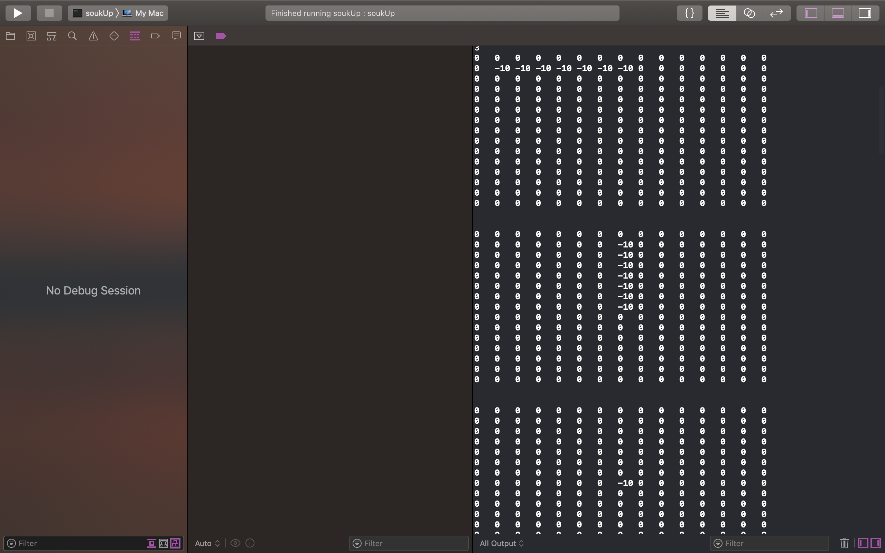

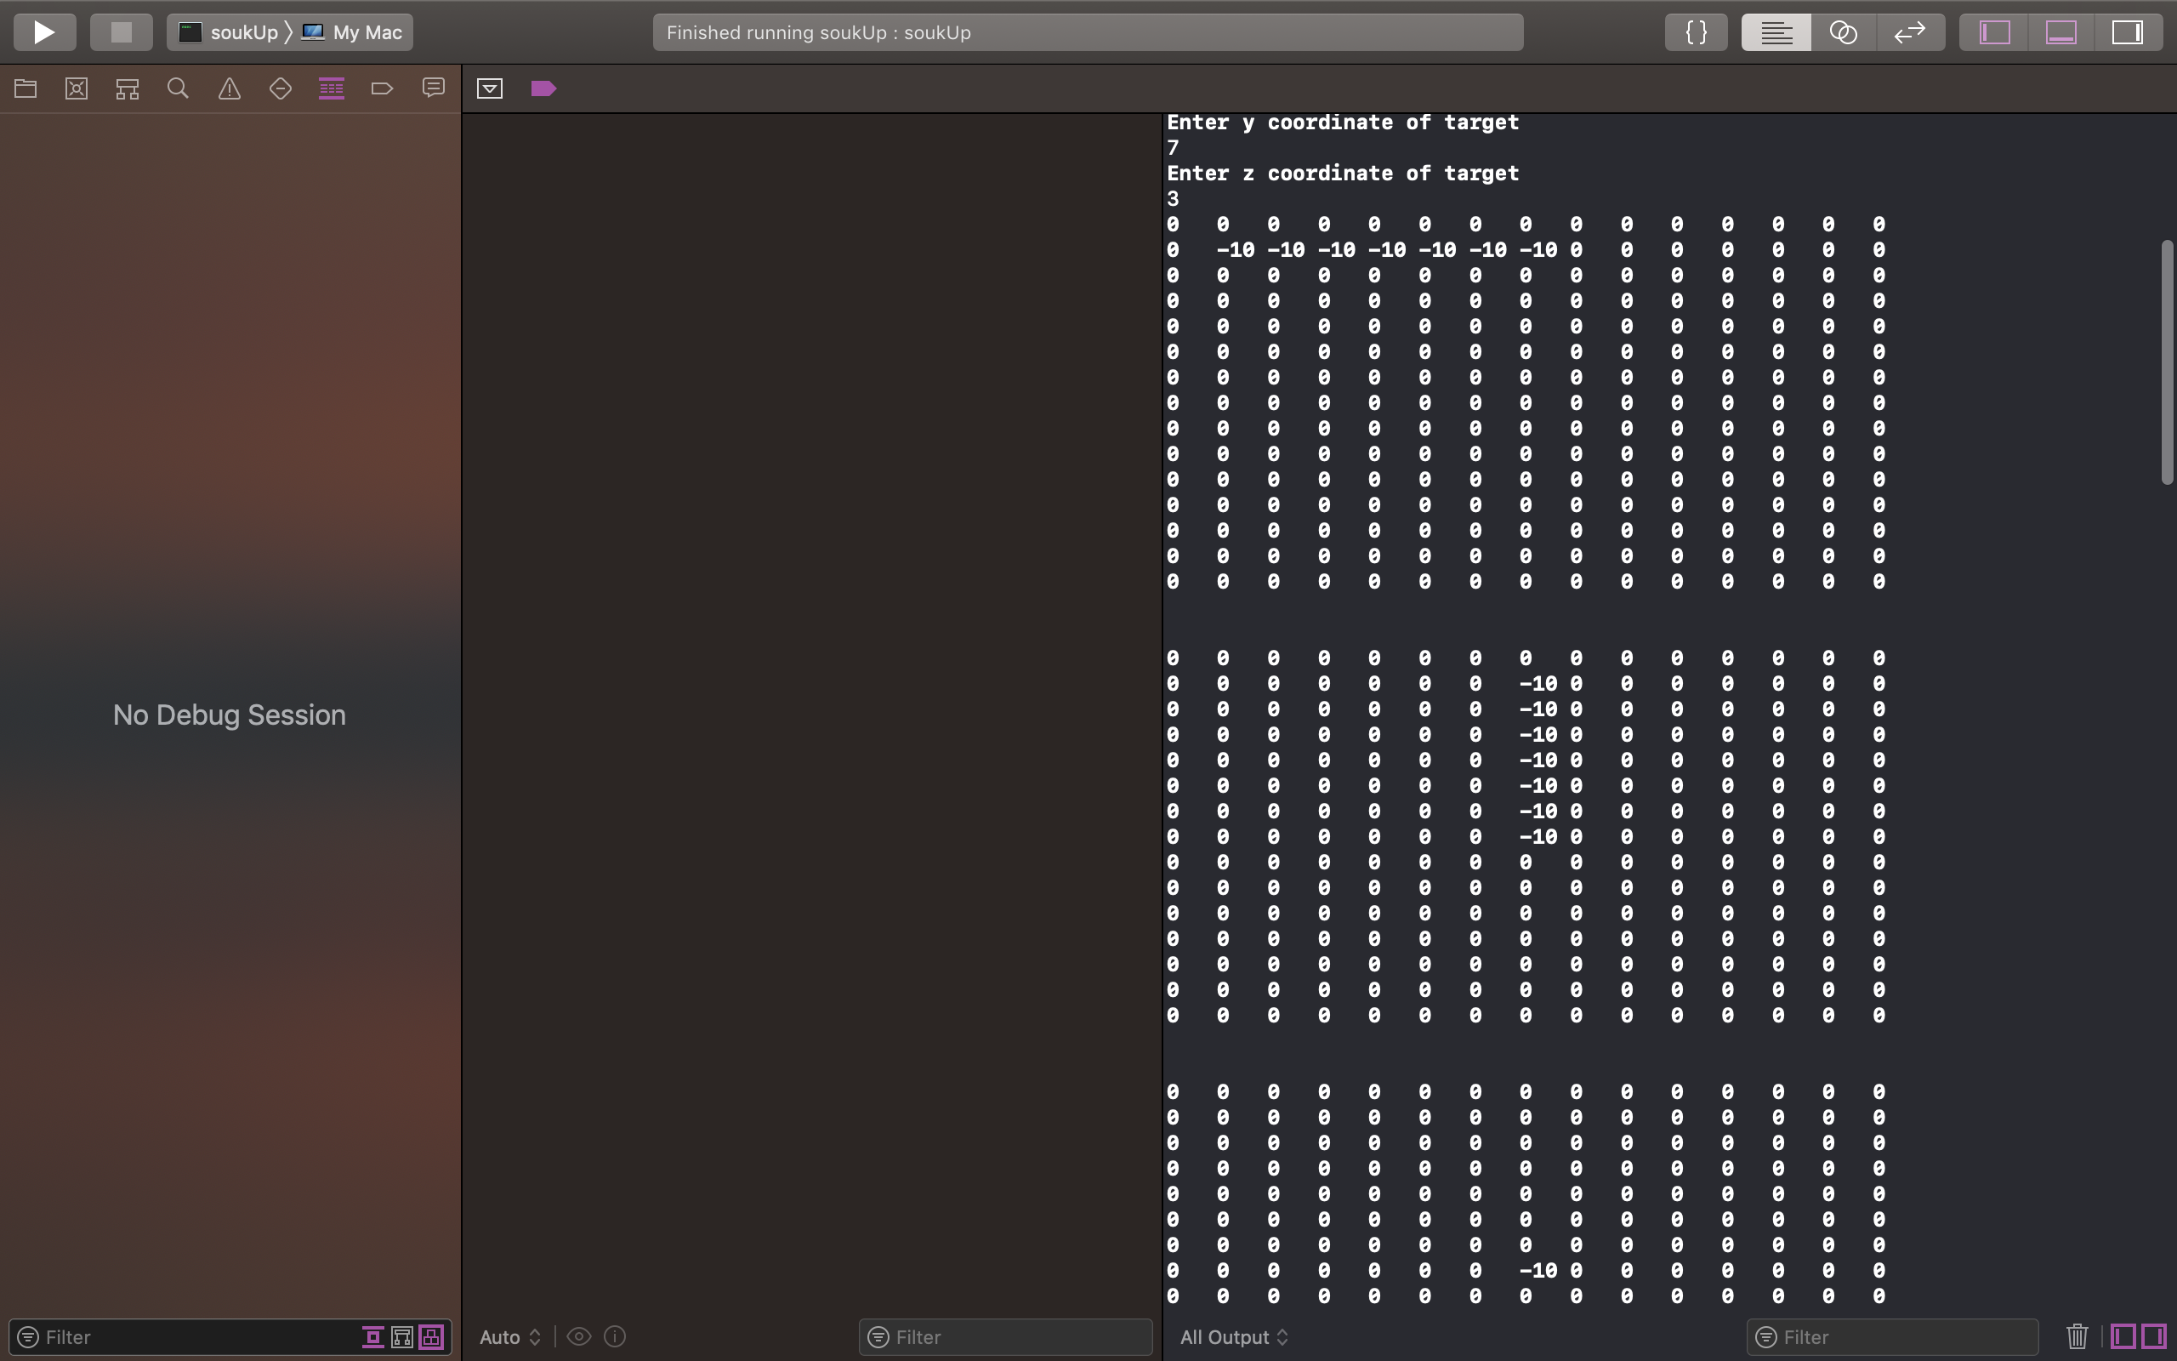

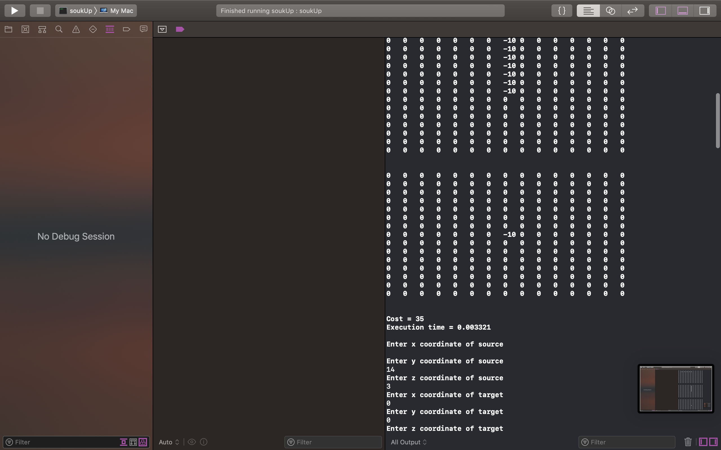

**Cost = 35**

**Execution time = 0.002981**

**Enter x coordinate of source**

14

**Enter y coordinate of source**

14

**Enter z coordinate of source**

3

**Enter x coordinate of target**

0

**Enter y coordinate of target**

0

**Enter z coordinate of target**

1

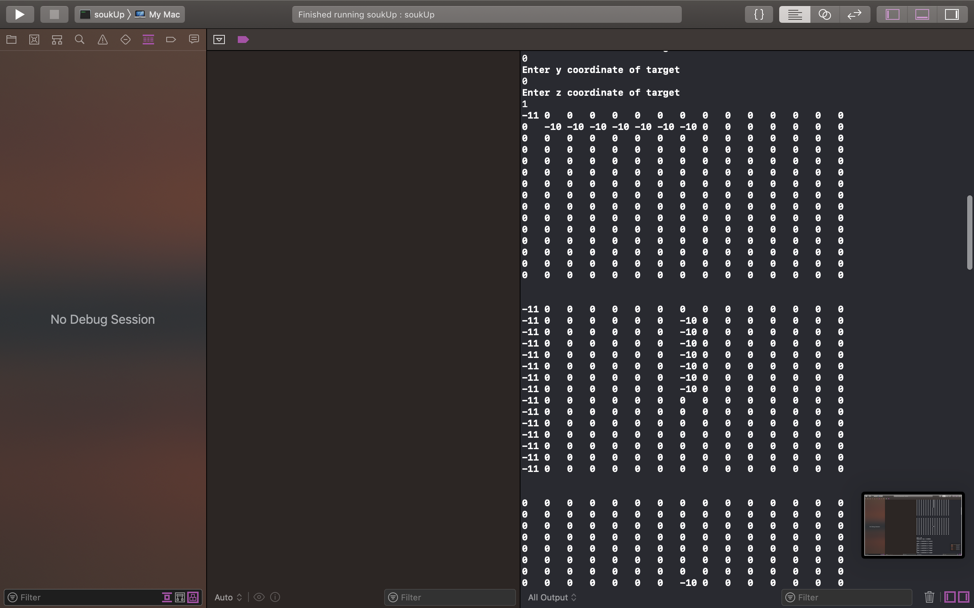



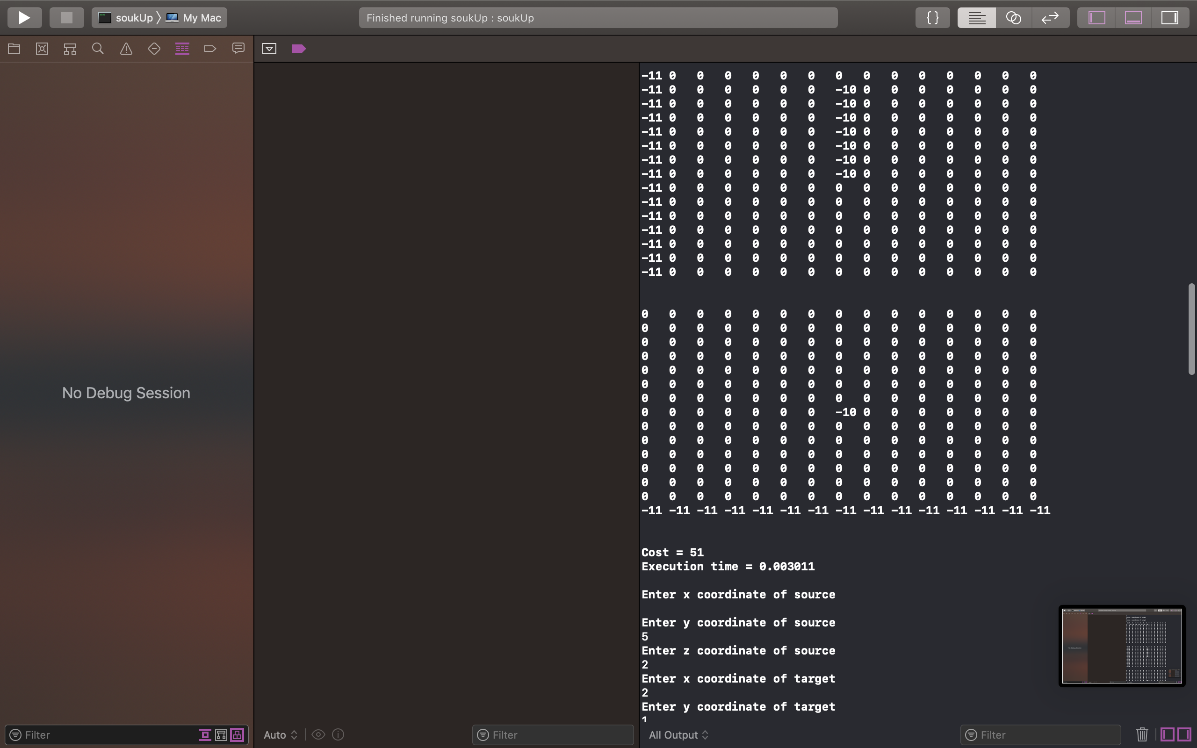

**Cost = 51**

**Execution time = 0.002903**

**Enter x coordinate of source**

5

**Enter y coordinate of source**

5

**Enter z coordinate of source**

2

**Enter x coordinate of target**

2

**Enter y coordinate of target**

1

**Enter z coordinate of target**

2

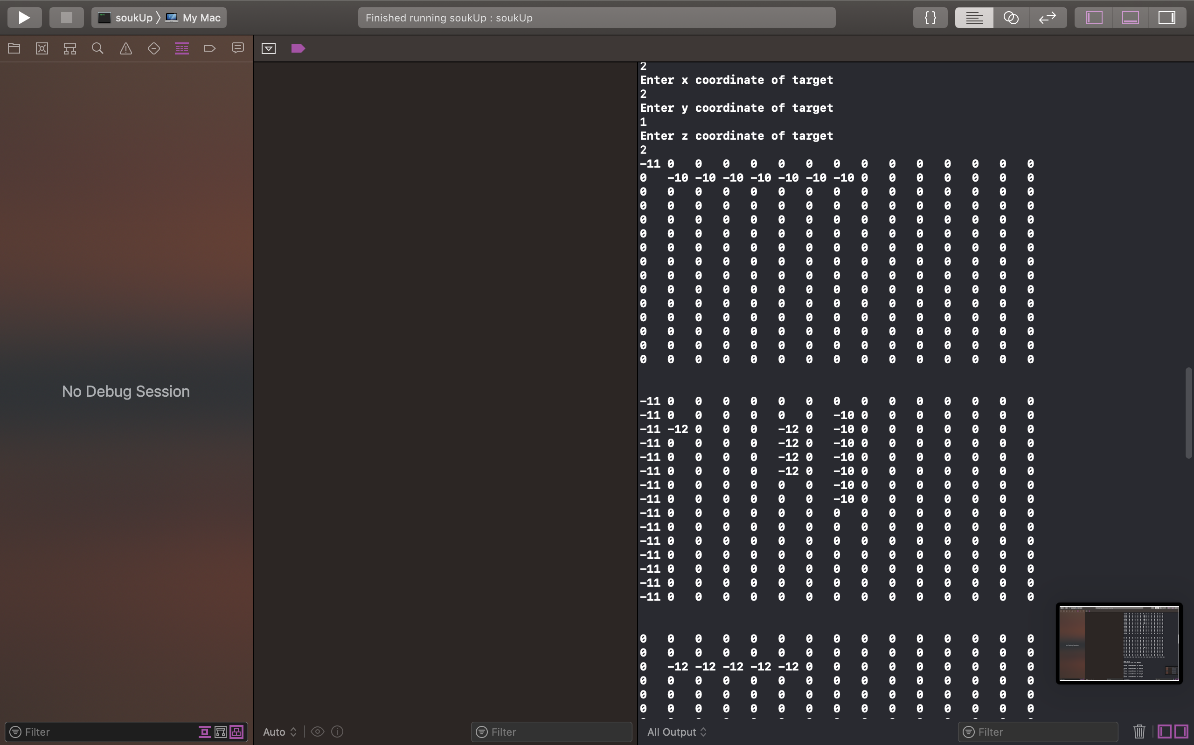

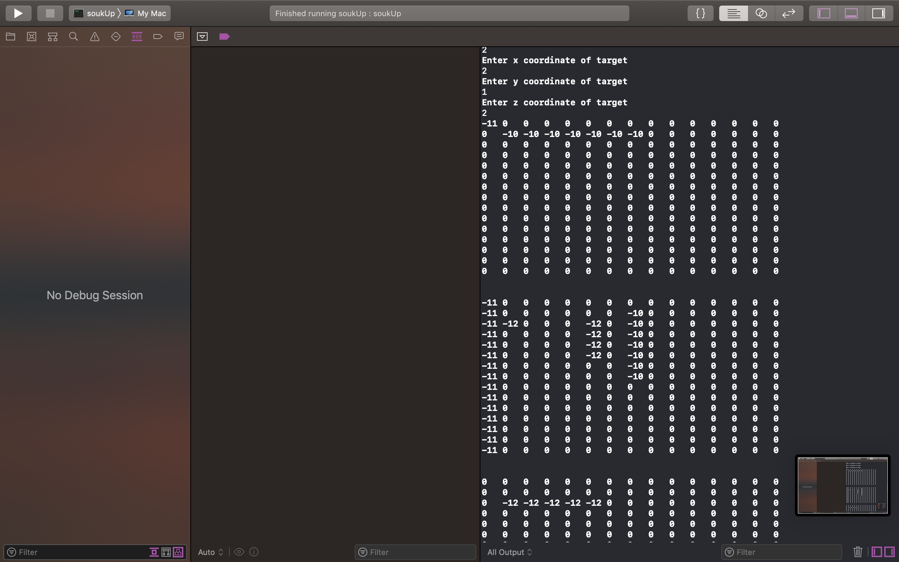

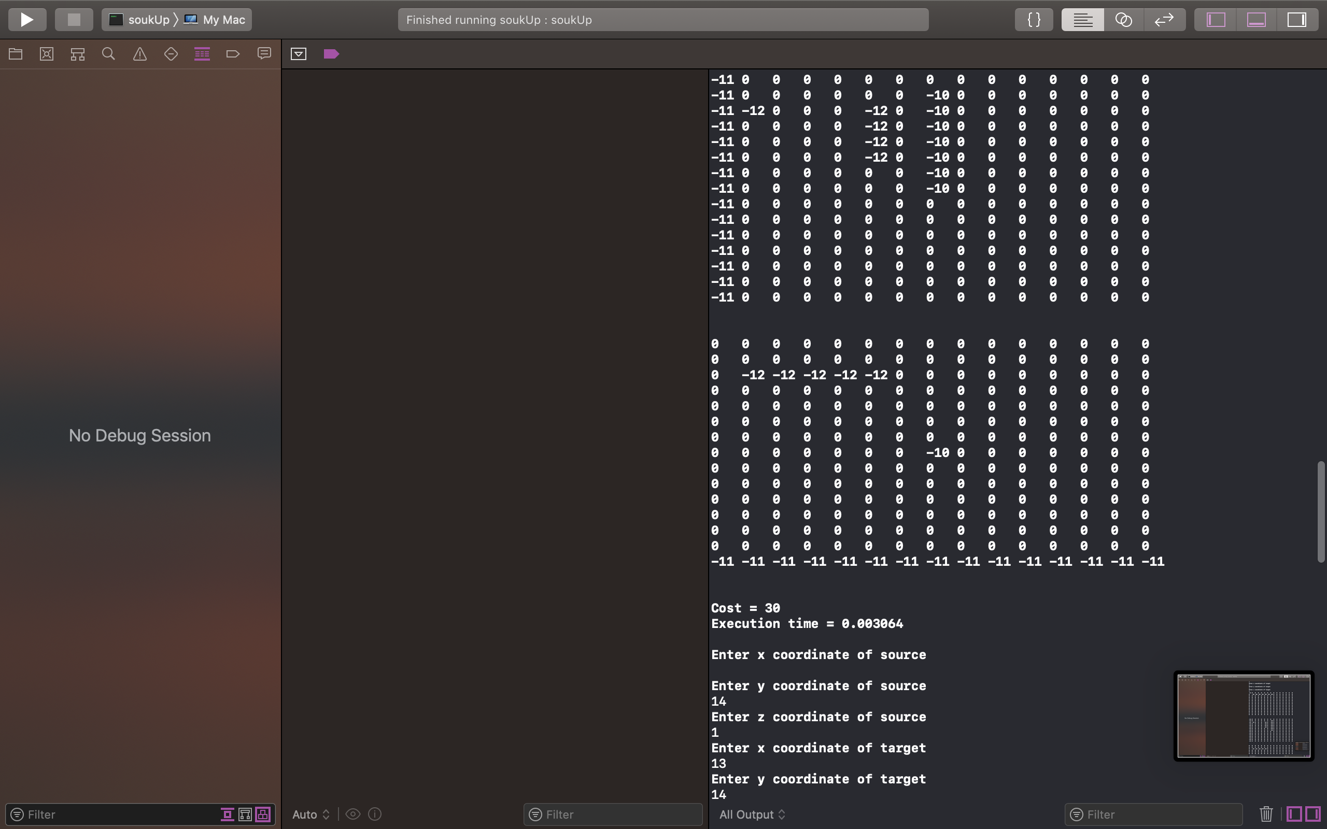

**Cost = 30**

**Execution time = 0.002751**

# Testcase 6 with results: (To showcase difference between floodless and classical)

**Please enter cost of via**

10

**Please enter the x-dimension of the plane**

15

**Please enter the y-dimension of the plane**

15

**If no path available, do you want to swap source and target and try again?**

**If yes enter 1, if no enter 0**

0

**Do you want to do DFS in more than one layer and thus flood less?**

**If yes enter 1, if no enter 0**

0

**Enter x coordinate of source**

1

**Enter y coordinate of source**

1

**Enter z coordinate of source**

1

**Enter x coordinate of target**

7

**Enter y coordinate of target**

7

**Enter z coordinate of target**

3

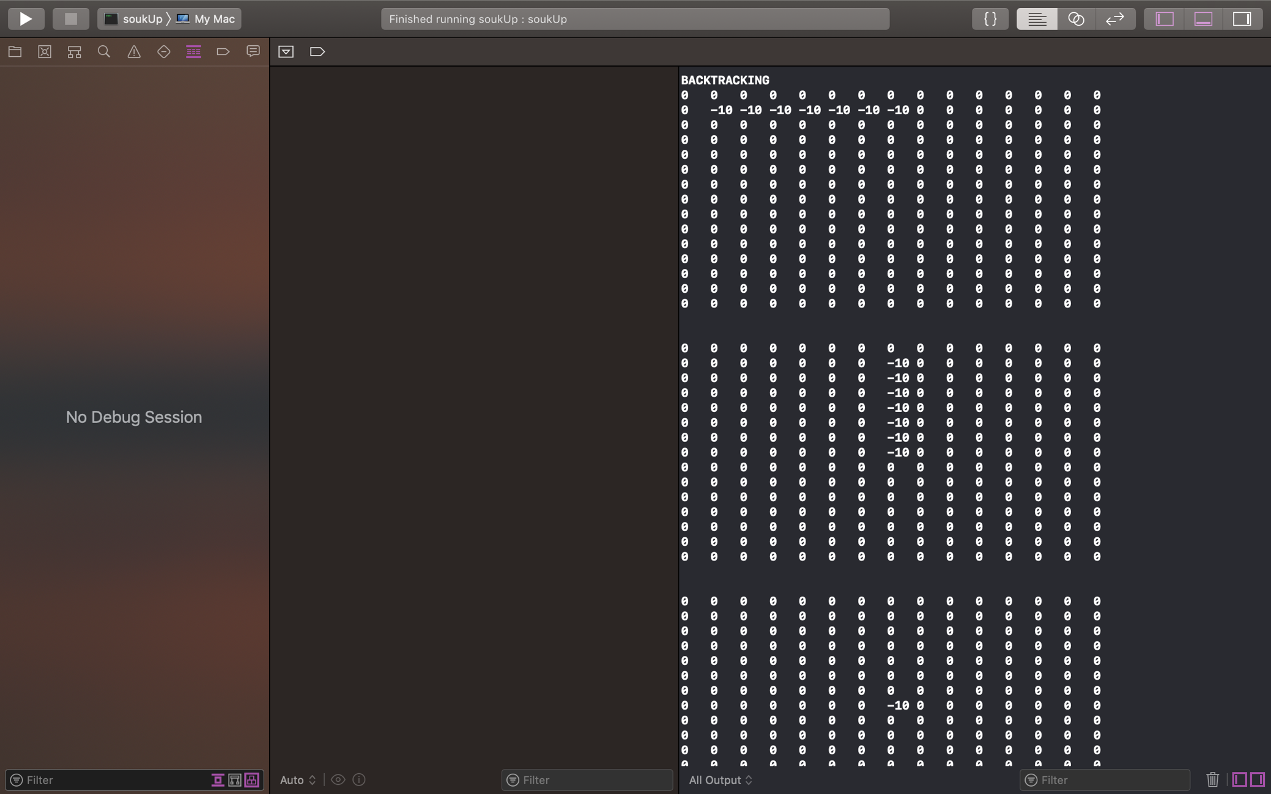

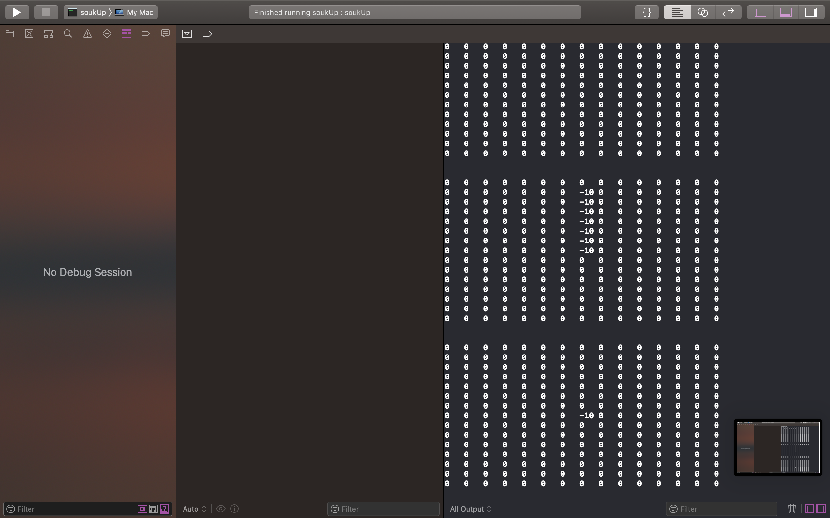

**Cost = 35**

**Execution time = 0.005312**

**Enter x coordinate of source**

14

**Enter y coordinate of source**

14

**Enter z coordinate of source**

3

**Enter x coordinate of target**

0

**Enter y coordinate of target**

0

**Enter z coordinate of target**

1

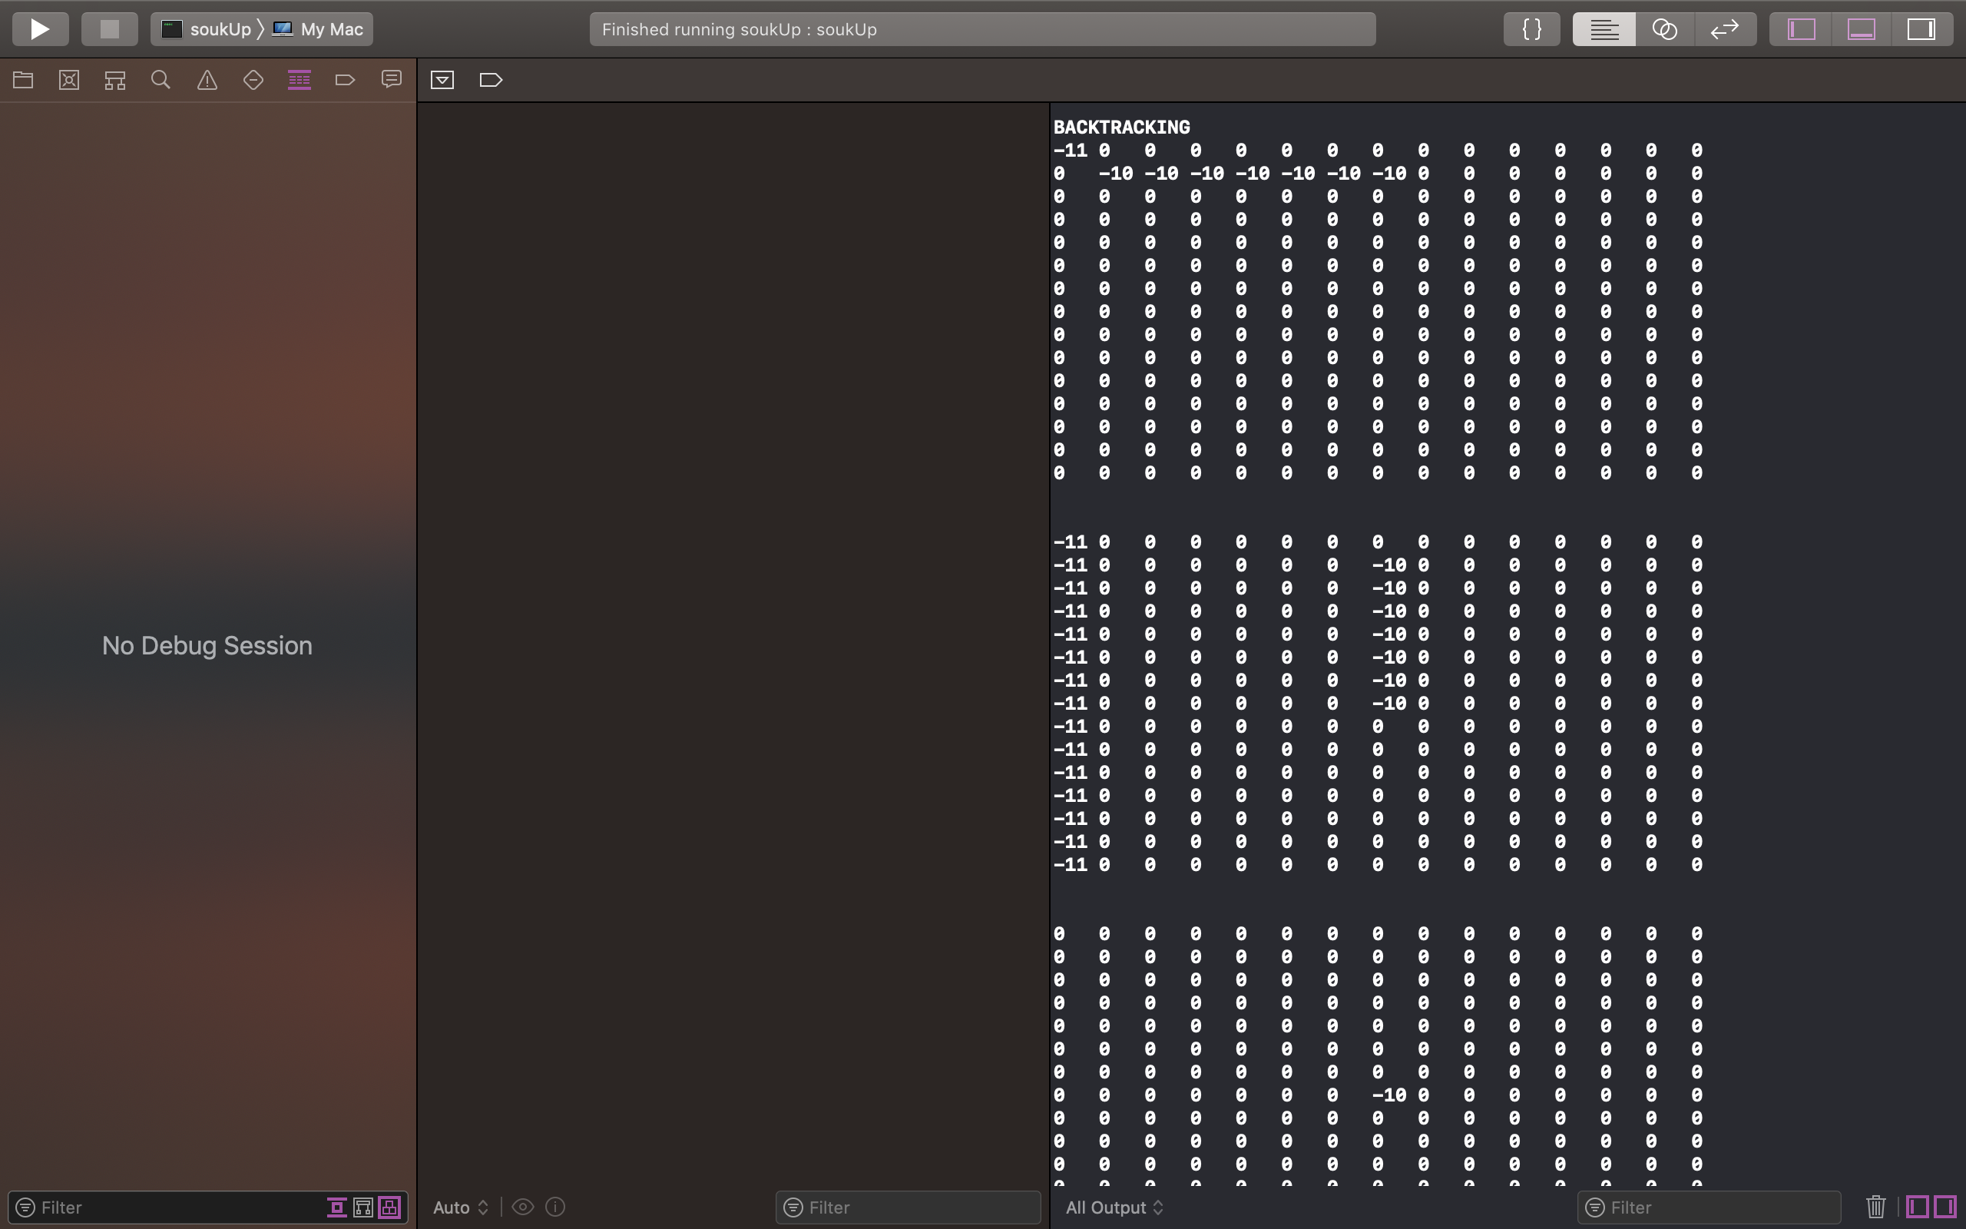

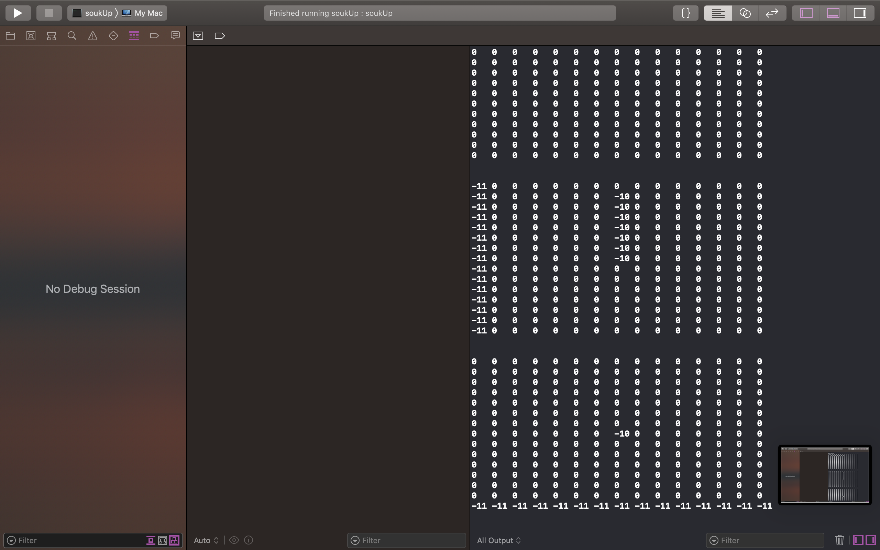

**Cost = 51**

**Execution time = 0.005454**

**Enter x coordinate of source**

5

**Enter y coordinate of source**

5

**Enter z coordinate of source**

2

**Enter x coordinate of target**

2

**Enter y coordinate of target**

1

**Enter z coordinate of target**

2

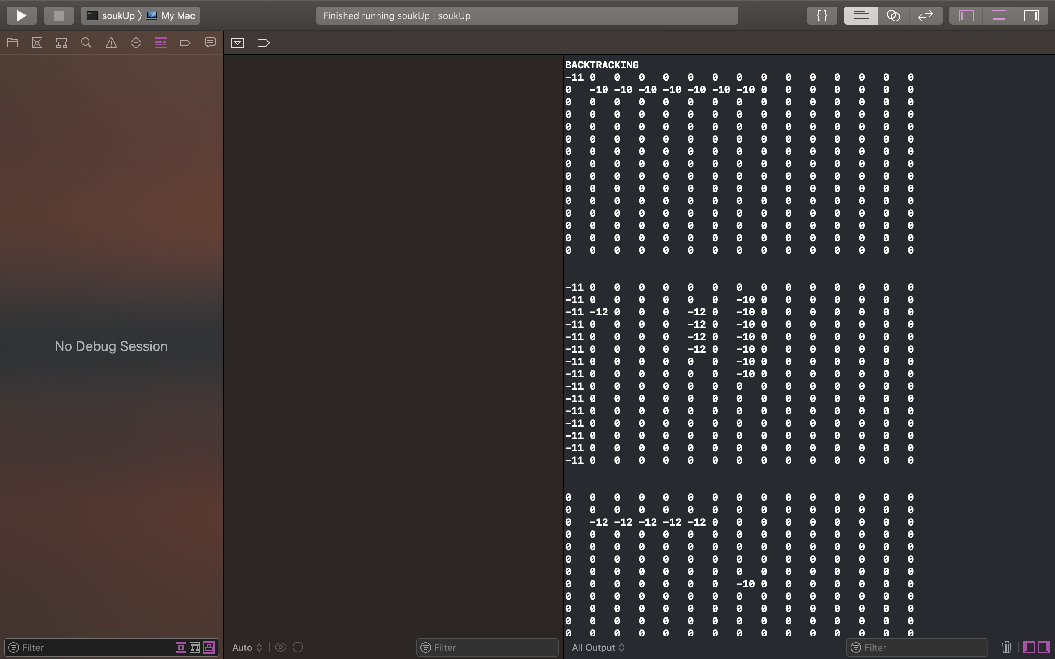

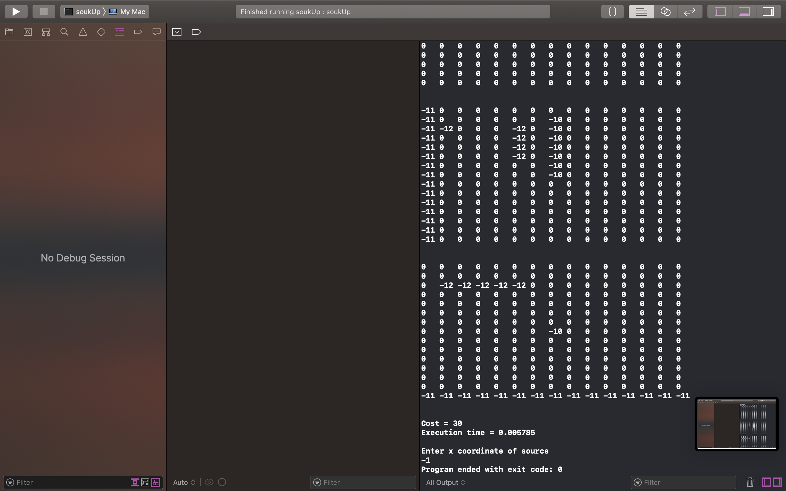

**Cost = 30**

**Execution time = 0.005785**

**Enter x coordinate of source**

-1

**Program ended with exit code: 0**

# Testcase 7:

**Please enter cost of via**

10

**Please enter the x-dimension of the plane**

5

**Please enter the y-dimension of the plane**

5

**If no path available, do you want to swap source and target and try again?**

**If yes enter 1, if no enter 0**

1

**Do you want to do DFS in more than one layer and thus flood less?**

**If yes enter 1, if no enter 0**

0

**Enter x coordinate of source**

1

**Enter y coordinate of source**

1

**Enter z coordinate of source**

1

**Enter x coordinate of target**

2

**Enter y coordinate of target**

3

**Enter z coordinate of target**

3

**BACKTRACKING**

**0 0 0 0 0**

**0 -10 -10 -10 0**

**0 0 0 0 0**

**0 0 0 0 0**

**0 0 0 0 0**

**0 0 0 0 0**

**0 0 0 -10 0**

**0 0 0 -10 0**

**0 0 0 0 0**

**0 0 0 0 0**

**0 0 0 0 0**

**0 0 0 0 0**

**0 0 0 -10 0**

**0 0 0 0 0**

**0 0 0 0 0**

**Cost = 26**

**Execution time = 0.001502**

**Enter x coordinate of source**

0

**Enter y coordinate of source**

0

**Enter z coordinate of source**

1

**Enter x coordinate of target**

3

**Enter y coordinate of target**

3

**Enter z coordinate of target**

2

**BACKTRACKING**

**-11 -11 -11 -11 -11**

**0 -10 -10 -10 0**

**0 0 0 0 0**

**0 0 0 0 0**

**0 0 0 0 0**

**0 0 0 0 -11**

**0 0 0 -10 -11**

**0 0 0 -10 -11**

**0 0 0 -11 -11**

**0 0 0 0 0**

**0 0 0 0 0**

**0 0 0 0 0**

**0 0 0 -10 0**

**0 0 0 -11 -11**

**0 0 0 0 0**

**Cost = 42**

**Execution time = 0.00096**

**Enter x coordinate of source**

0

**Enter y coordinate of source**

0

**Enter z coordinate of source**

1

**Enter x coordinate of target**

1

**Enter y coordinate of target**

0

**Enter z coordinate of target**

1

**BACKTRACKING**

**-12 -11 -11 -11 -11**

**-12 -10 -10 -10 0**

**0 0 0 0 0**

**0 0 0 0 0**

**0 0 0 0 0**

**-12 0 0 0 -11**

**-12 0 0 -10 -11**

**0 0 0 -10 -11**

**0 0 0 -11 -11**

**0 0 0 0 0**

**0 0 0 0 0**

**0 0 0 0 0**

**0 0 0 -10 0**

**0 0 0 -11 -11**

**0 0 0 0 0**

**Cost = 24**

**Execution time = 0.000757**

**Enter x coordinate of source**

0

**Enter y coordinate of source**

1

**Enter z coordinate of source**

1

**Enter x coordinate of target**

2

**Enter y coordinate of target**

5

**Enter y coordinate of target**

3

**Enter z coordinate of target**

3

**BACKTRACKING**

**-12 -13 -11 -11 -11**

**-12 -10 -10 -10 0**

**0 0 0 0 0**

**0 0 0 0 0**

**0 0 0 0 0**

**-12 -13 0 0 -11**

**-12 -13 0 -10 -11**

**0 -13 0 -10 -11**

**0 0 0 -11 -11**

**0 0 0 0 0**

**0 0 0 0 0**

**0 0 0 0 0**

**0 -13 -13 -13 0**

**0 0 0 -11 -11**

**0 0 0 0 0**

**Cost = 27**

**Execution time = 0.000888**

**Enter x coordinate of source**

1

**Enter y coordinate of source**

0

**Enter z coordinate of source**

1

**Enter x coordinate of target**

0

**Enter y coordinate of target**

3

**Enter z coordinate of target**

2

**No Path available**

**-12 -13 -11 -11 -11**

**-12 -10 -10 -10 0**

**0 0 0 0 0**

**0 0 0 0 0**

**0 0 0 0 0**

**-12 -13 0 0 -11**

**-12 -13 0 -10 -11**

**0 -13 0 -10 -11**

**0 0 0 -11 -11**

**0 0 0 0 0**

**0 0 0 0 0**

**0 0 0 0 0**

**0 -13 -13 -13 0**

**0 0 0 -11 -11**

**0 0 0 0 0**

**Execution time = 0.001182**

**Enter x coordinate of source**

4

**Enter y coordinate of source**

4

**Enter z coordinate of source**

3

**Enter x coordinate of target**

1

**Enter y coordinate of target**

1

**Enter z coordinate of target**

1

**No Path available**

**-12 -13 -11 -11 -11**

**-12 -10 -10 -10 0**

**0 0 0 0 0**

**0 0 0 0 0**

**0 0 0 0 0**

**-12 -13 0 0 -11**

**-12 -13 0 -10 -11**

**0 -13 0 -10 -11**

**0 0 0 -11 -11**

**0 0 0 0 0**

**0 0 0 0 0**

**0 0 0 0 0**

**0 -13 -13 -13 0**

**0 0 0 -11 -11**

**0 0 0 0 0**

**Execution time = 0.001448**

**Enter x coordinate of source**

-1

**Program ended with exit code: 0**

# Testcase 9:

**Please enter cost of via**

10

**Please enter the x-dimension of the plane**

7

**Please enter the y-dimension of the plane**

3

**If no path available, do you want to swap source and target and try again?**

**If yes enter 1, if no enter 0**

1

**Do you want to do DFS in more than one layer and thus flood less?**

**If yes enter 1, if no enter 0**

0

**Enter x coordinate of source**

1

**Enter y coordinate of source**

1

**Enter z coordinate of source**

1

**Enter x coordinate of target**

2

**Enter y coordinate of target**

1

**Enter z coordinate of target**

3

**Flooding**

**0 22 0**

**2 1 2**

**0 22 0**

**0 0 0**

**0 0 0**

**0 0 0**

**0 0 0**

**13 12 13**

**12 11 12**

**13 12 13**

**0 0 0**

**0 0 0**

**0 0 0**

**0 0 0**

**0 22 0**

**22 21 22**

**0 22 0**

**0 0 0**

**0 0 0**

**0 0 0**

**0 0 0**

**BACKTRACKING**

**0 0 0**

**0 -10 0**

**0 0 0**

**0 0 0**

**0 0 0**

**0 0 0**

**0 0 0**

**0 0 0**

**0 -10 0**

**0 -10 0**

**0 0 0**

**0 0 0**

**0 0 0**

**0 0 0**

**0 0 0**

**0 0 0**

**0 -10 0**

**0 0 0**

**0 0 0**

**0 0 0**

**0 0 0**

**Cost = 24**

**Execution time = 0.001109**

**Enter x coordinate of source**

0

**Enter y coordinate of source**

0

**Enter z coordinate of source**

1

**Enter x coordinate of target**

6

**Enter y coordinate of target**

3

**Enter y coordinate of target**

2

**Enter z coordinate of target**

3

**Flooding**

**-11 -11 1**

**0 -10 22**

**0 0 23**

**0 0 24**

**0 0 25**

**0 0 26**

**0 0 27**

**0 0 11**

**0 -10 12**

**0 -10 13**

**0 0 14**

**0 0 15**

**0 0 16**

**0 0 17**

**0 0 21**

**0 0 22**

**0 -10 23**

**0 0 24**

**0 0 25**

**0 0 26**

**0 0 27**

**BACKTRACKING**

**-11 -11 -11**

**0 -10 0**

**0 0 0**

**0 0 0**

**0 0 0**

**0 0 0**

**0 0 0**

**0 0 -11**

**0 -10 -11**

**0 -10 -11**

**0 0 -11**

**0 0 -11**

**0 0 -11**

**0 0 -11**

**0 0 0**

**0 0 0**

**0 -10 0**

**0 0 0**

**0 0 0**

**0 0 0**

**0 0 -11**

**Cost = 31**

**Execution time = 0.001236**

**Enter x coordinate of source**

1

**Enter y coordinate of source**

0

**Enter z coordinate of source**

1

**Enter x coordinate of target**

1

**Enter y coordinate of target**

0

**Enter z coordinate of target**

1

**-11 -11 -11**

**-12 -10 0**

**0 0 0**

**0 0 0**

**0 0 0**

**0 0 0**

**0 0 0**

**0 0 -11**

**0 -10 -11**

**0 -10 -11**

**0 0 -11**

**0 0 -11**

**0 0 -11**

**0 0 -11**

**0 0 0**

**0 0 0**

**0 -10 0**

**0 0 0**

**0 0 0**

**0 0 0**

**0 0 -11**

**Cost = 1**

**Execution time = 0.000376**

**Enter x coordinate of source**

5

**Enter y coordinate of source**

2

**Enter z coordinate of source**

3

**Enter x coordinate of target**

1

**Enter y coordinate of target**

0

**Enter z coordinate of target**

1

**Flooding**

**-11 -11 -11**

**25 -10 0**

**24 0 0**

**23 0 0**

**22 0 0**

**21 0 0**

**22 0 0**

**0 0 -11**

**15 -10 -11**

**14 -10 -11**

**13 0 -11**

**12 0 -11**

**11 0 -11**

**12 0 -11**

**0 0 0**

**0 0 0**

**24 -10 0**

**23 0 0**

**22 0 0**

**1 -13 -13**

**22 0 -11**

**BACKTRACKING**

**-11 -11 -11**

**-13 -10 0**

**0 0 0**

**0 0 0**

**0 0 0**

**0 0 0**

**0 0 0**

**0 0 -11**

**-13 -10 -11**

**-13 -10 -11**

**-13 0 -11**

**-13 0 -11**

**-13 0 -11**

**0 0 -11**

**0 0 0**

**0 0 0**

**0 -10 0**

**0 0 0**

**0 0 0**

**-13 -13 -13**

**0 0 -11**

**Cost = 29**

**Execution time = 0.001121**

**Enter x coordinate of source**

1

**Enter y coordinate of source**

2

**Enter z coordinate of source**

1

**Enter x coordinate of target**

4

**Enter y coordinate of target**

0

**Enter z coordinate of target**

3

**Flooding**

**-11 -11 -11**

**-13 -10 1**

**0 0 0**

**0 0 0**

**0 0 0**

**0 0 0**

**0 0 0**

**0 0 -11**

**-13 -10 -11**

**-13 -10 -11**

**-13 0 -11**

**-13 0 -11**

**-13 0 -11**

**0 0 -11**

**0 0 0**

**0 0 0**

**0 -10 0**

**0 0 0**

**0 0 0**

**-13 -13 -13**

**0 0 -11**

**Flooding**

**-11 -11 -11**

**-13 -10 0**

**0 0 0**

**0 0 0**

**0 0 0**

**0 0 0**

**0 0 0**

**0 0 -11**

**-13 -10 -11**

**-13 -10 -11**

**-13 0 -11**

**-13 0 -11**

**-13 0 -11**

**0 0 -11**

**0 0 0**

**0 0 0**

**0 -10 0**

**0 0 0**

**-14 -14 1**

**-13 -13 -13**

**0 0 -11**

**No Path available**

**-11 -11 -11**

**-13 -10 0**

**0 0 0**

**0 0 0**

**0 0 0**

**0 0 0**

**0 0 0**

**0 0 -11**

**-13 -10 -11**

**-13 -10 -11**

**-13 0 -11**

**-13 0 -11**

**-13 0 -11**

**0 0 -11**

**0 0 0**

**0 0 0**

**0 -10 0**

**0 0 0**

**0 0 0**

**-13 -13 -13**

**0 0 -11**

**Execution time = 0.001086**

**Enter x coordinate of source**

-1

**Program ended with exit code: 0**

# Testcase 11:

**Please enter cost of via**

10

**Please enter the x-dimension of the plane**

7

**Please enter the y-dimension of the plane**

3

**If no path available, do you want to swap source and target and try again?**

**If yes enter 1, if no enter 0**

1

**Do you want to do DFS in more than one layer and thus flood less?**

**If yes enter 1, if no enter 0**

1

**Enter x coordinate of source**

1

**Enter y coordinate of source**

1

**Enter z coordinate of source**

1

**Enter x coordinate of target**

2

**Enter y coordinate of target**

1

**Enter z coordinate of target**

3

**BACKTRACKING**

**0 0 0**

**0 -10 0**

**0 0 0**

**0 0 0**

**0 0 0**

**0 0 0**

**0 0 0**

**0 0 0**

**0 -10 0**

**0 -10 0**

**0 0 0**

**0 0 0**

**0 0 0**

**0 0 0**

**0 0 0**

**0 0 0**

**0 -10 0**

**0 0 0**

**0 0 0**

**0 0 0**

**0 0 0**

**Cost = 24**

**Execution time = 0.000931**

**Enter x coordinate of source**

0

**Enter y coordinate of source**

0

**Enter z coordinate of source**

1

**Enter x coordinate of target**

6

**Enter y coordinate of target**

2

**Enter z coordinate of target**

3

**-11 -11 -11**

**0 -10 0**

**0 0 0**

**0 0 0**

**0 0 0**

**0 0 0**

**0 0 0**

**0 0 -11**

**0 -10 -11**

**0 -10 -11**

**0 0 -11**

**0 0 -11**

**0 0 -11**

**0 0 -11**

**0 0 0**

**0 0 0**

**0 -10 0**

**0 0 0**

**0 0 0**

**0 0 0**

**0 0 -11**

**Cost = 31**

**Execution time = 0.000452**

**Enter x coordinate of source**

1

**Enter y coordinate of source**

0

**Enter z coordinate of source**

1

**Enter x coordinate of target**

1

**Enter y coordinate of target**

0

**Enter z coordinate of target**

1

**-11 -11 -11**

**-12 -10 0**

**0 0 0**

**0 0 0**

**0 0 0**

**0 0 0**

**0 0 0**

**0 0 -11**

**0 -10 -11**

**0 -10 -11**

**0 0 -11**

**0 0 -11**

**0 0 -11**

**0 0 -11**

**0 0 0**

**0 0 0**

**0 -10 0**

**0 0 0**

**0 0 0**

**0 0 0**

**0 0 -11**

**Cost = 1**

**Execution time = 0.000391**

**Enter x coordinate of source**

5

**Enter y coordinate of source**

2

**Enter z coordinate of source**

3

**Enter x coordinate of target**

1

**Enter y coordinate of target**

0

**Enter z coordinate of target**

1

**-11 -11 -11**

**-13 -10 0**

**0 0 0**

**0 0 0**

**0 0 0**

**0 0 0**

**0 0 0**

**0 0 -11**

**-13 -10 -11**

**-13 -10 -11**

**-13 0 -11**

**-13 0 -11**

**-13 0 -11**

**0 0 -11**

**0 0 0**

**0 0 0**

**0 -10 0**

**0 0 0**

**0 0 0**

**-13 -13 -13**

**0 0 -11**

**Cost = 29**

**Execution time = 0.00046**

**Enter x coordinate of source**

1

**Enter y coordinate of source**

2

**Enter z coordinate of source**

1

**Enter x coordinate of target**

4

**Enter y coordinate of target**

0

**Enter z coordinate of target**

3

**No Path available**

**-11 -11 -11**

**-12 -10 0**

**0 0 0**

**0 0 0**

**0 0 0**

**0 0 0**

**0 0 0**

**0 0 -11**

**-13 -10 -11**

**-13 -10 -11**

**-13 0 -11**

**-13 0 -11**

**-13 0 -11**

**0 0 -11**

**0 0 0**

**0 0 0**

**0 -10 0**

**0 0 0**

**0 0 0**

**-13 -13 -13**

**0 0 -11**

**Execution time = 0.000674**

**Enter x coordinate of source**

-1

**Program ended with exit code: 0**